C
Salmorejo Cordobés
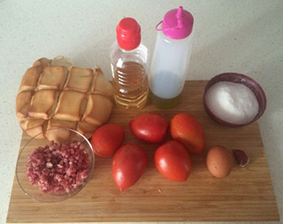 | 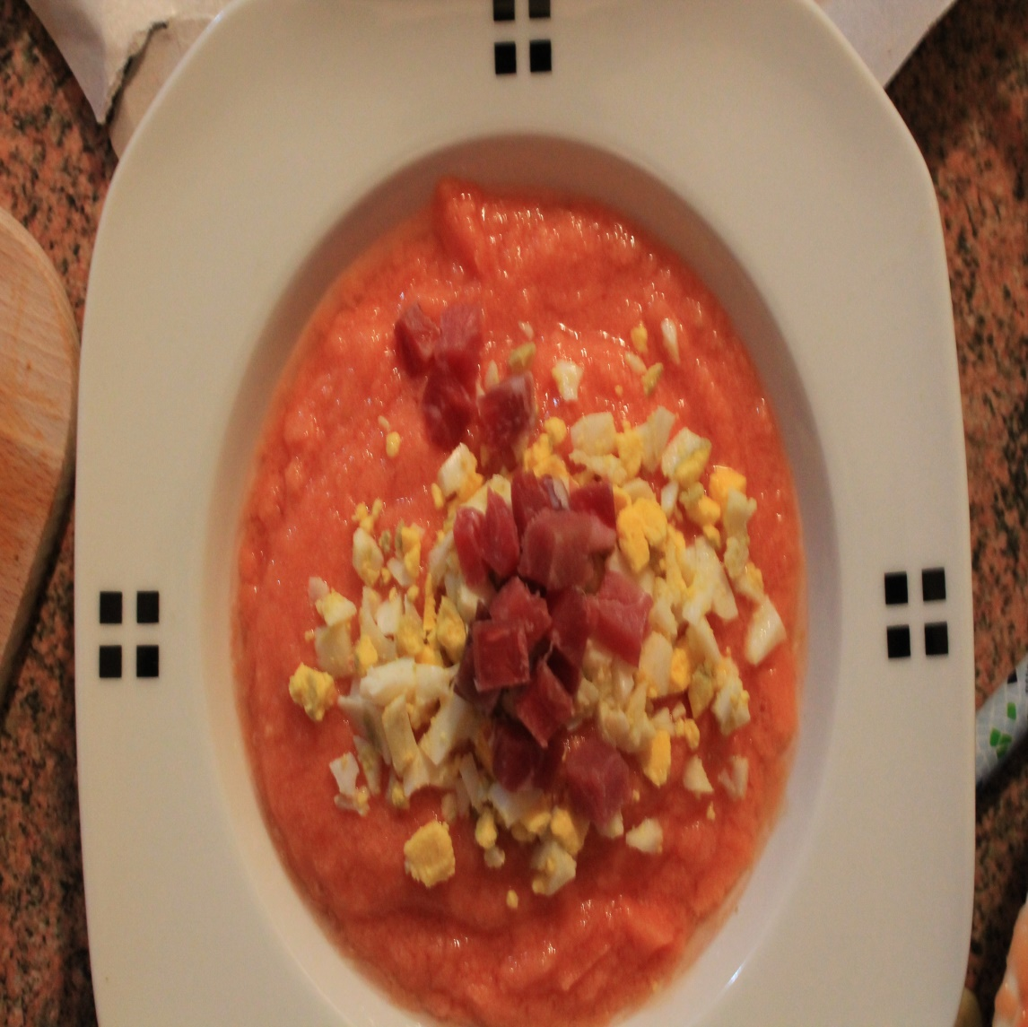

Recipe created by Clara Paniagua, Cati Penes y Á

Cordovan Salmorejo
Cordovan Salmorejo is a tomatoes soup with jamón serrano and boiled eggs  Preparation:  The tomatoes should be peeled. Chop the tomatoes up and put them in the food blender with the oil, garlic and a little salt. Blend this all together and then start to add the stale bread bit by bit. The mixture will very quickly become thicker and as you add the bread it will take longer for it to mix through. When no more bread will mix through it the Salmorejo is ready. You may not need to add all the bread or you may need a bit more.  Put the Salmorejo into a bowl and chill it in the fridge.  Just before serving garnish with chopped up egg white and jamón serrano.  time KCal People Style Type Level Cost  30 minutes 175 3-4 vegetable starter easy cheap | Ingredients:  500 g very ripe, very red tomatoes  1 clove of garlic  4 soup spoons of virgen olive oil  Salt  2 hard boiled eggs and some chopped up jamón serrano to put on top  1 stale spanish/french stick bread (the quantity of bread may vary) – By stale bread I mean that it should be very dry (but not mouldy)  History:  This recipe is a tipycal Andalusian food like gazpacho

Ensalada Campera
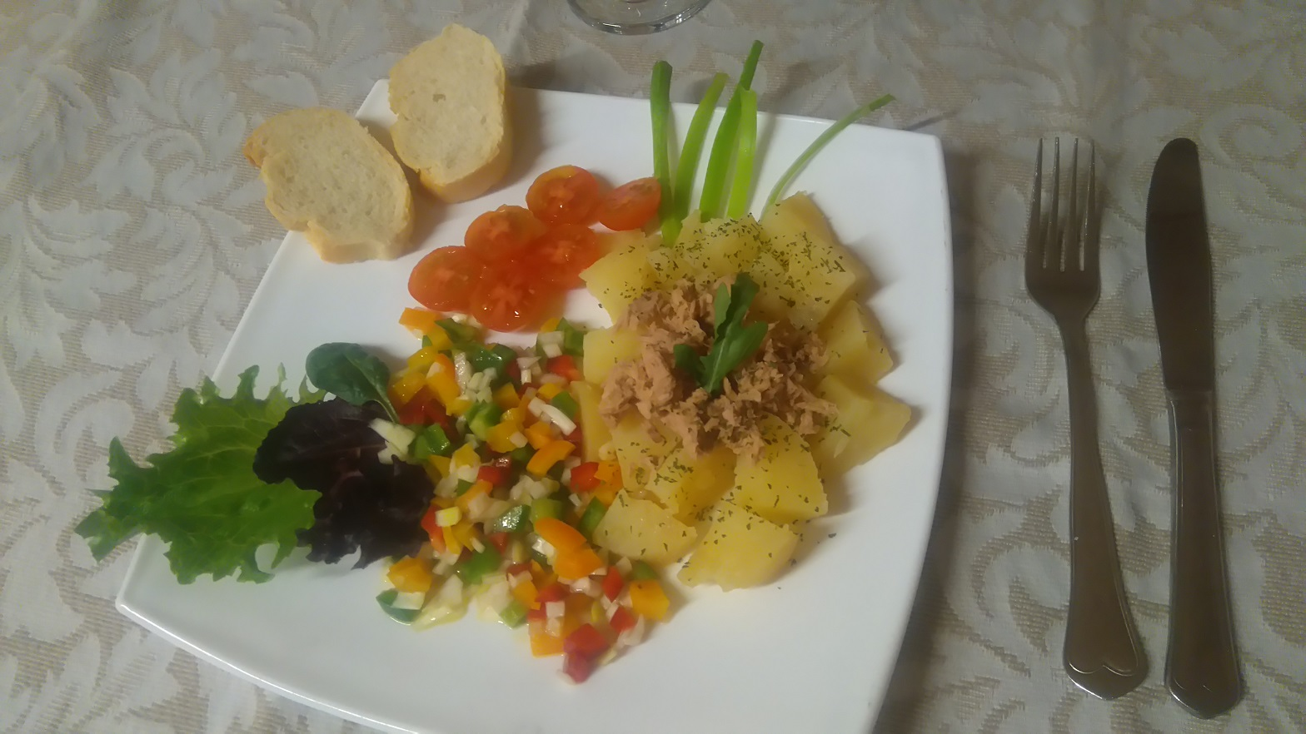

Recipe created by Irene Gomez Cedenilla

Country Salad
It is a healthy and fresh salad - perfect to eat in summer.  Preparation:  First boil the potatoes.  Then cut the pepper and the onion, mix them and add olive oil, salt and vinegar.  Now, peel the potatoes and chop them into dices.  Then mix the pepper and the onion with the potatoes and add the tuna and the tomatoes. And it is done!  time KCal People Style Type Level Cost  15 minutes 250 4 salad starter easy expensive | Ingredients:  Pepper, onion, potatoes, tomatoes, tuna, olive oil, salt and vinegar.  Tips:  You can also add sauces like mayonnaise.  You can add more vegetables like corn or lettuce.

Zupa ogórkowa
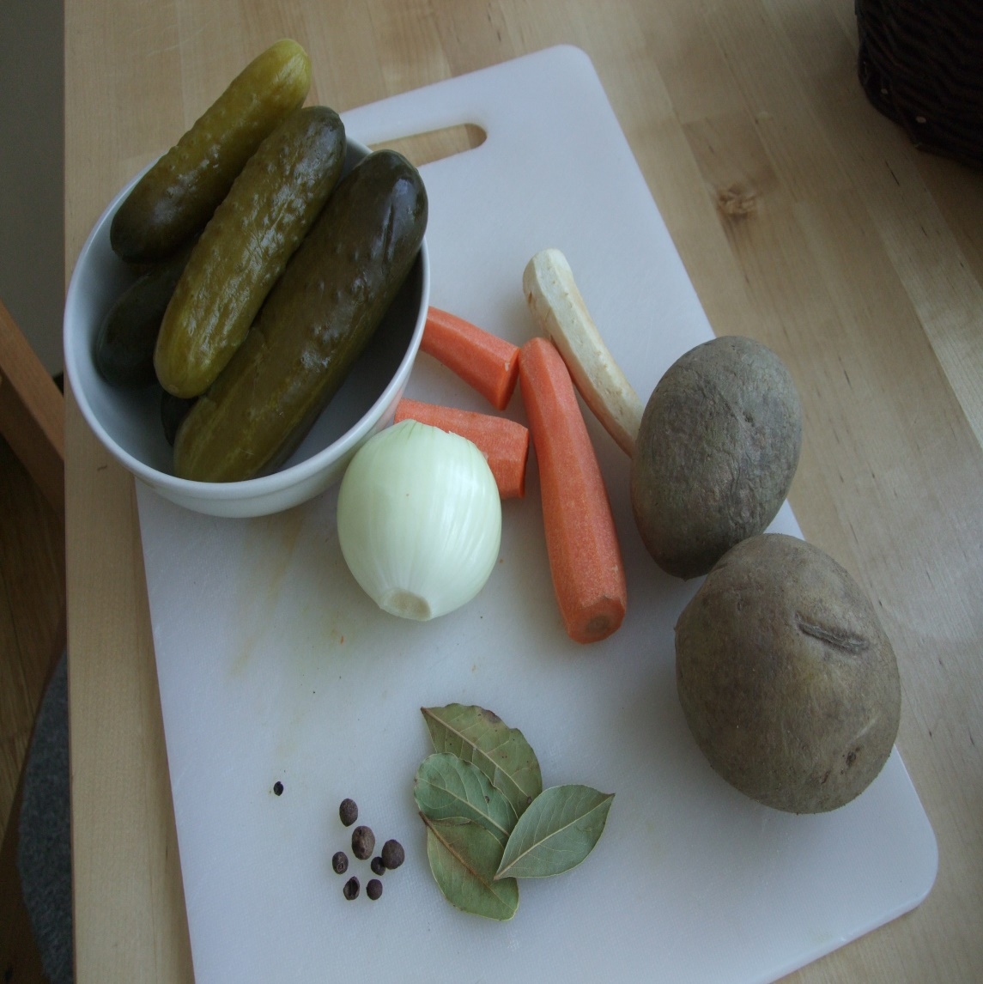 | 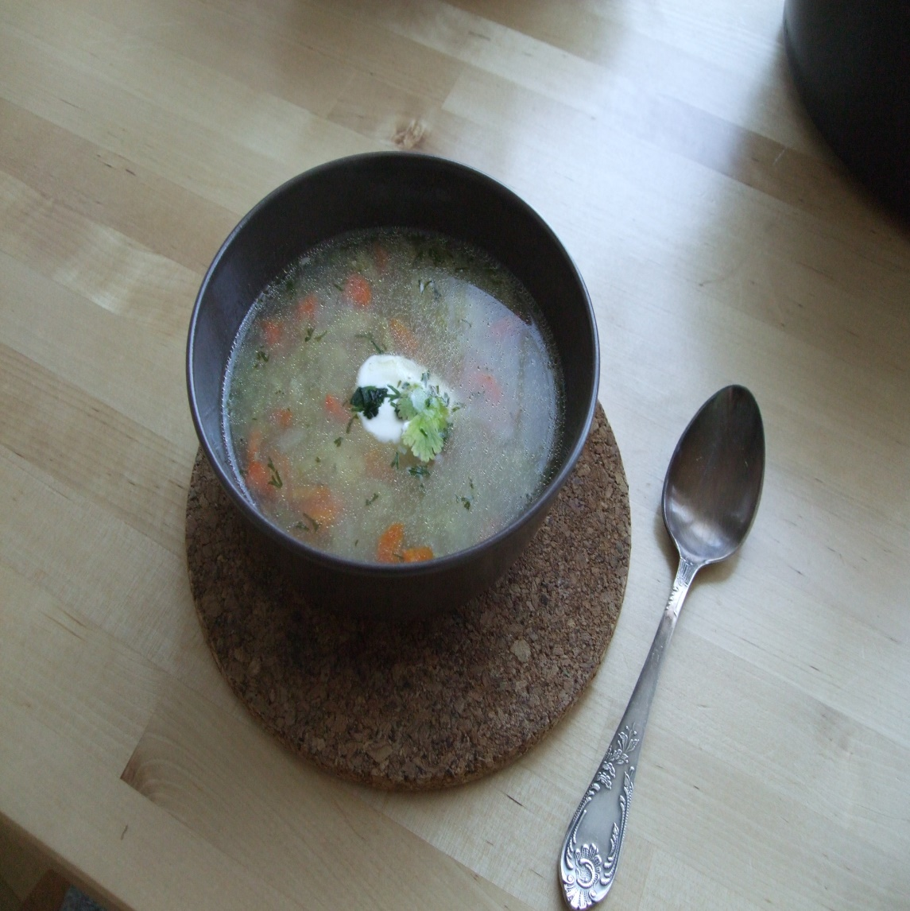

Recipe created by Kasia Kaca

Cucumber in brine soup
Cucumber in brine soup is a traditional Polish starter that was often cooked by many generations of Polish housewives. Its smell is associated with the Sunday home-made lunch. The recipe is very simple and the soup is really tasty.  Preparation:  Put the rinsed meat into the pot. Cook slowly until it boils. Add a pinch of salt, bay leaf and allspice. Add chopped vegetables: carrot, parsley, celery, potatoes and a stock cube. In the meanwhile peel and grate cucumbers. When the vegetables are soft, add the cucumbers to the pot. Cook for 10 more minutes and season with salt and peper.  time KCal People Style Type Level Cost  about 20 minutes 175 4 soup starter easy cheap | Ingredients:  Ingredients for cucumber in brine soup ( Serving for 4 people):  - 4-5 cucumbers in brine  - 3-4 tablespoons of cream (not straight from the fridge )  - Two ribs or 3 wings  - 1 stock cube  - 2-3 carrots  - 1 parsley  - a piece of celery  - 4-5 potatoes  - Bay leaf  - 2-3 grains allspice  - Salt and pepper  History:  I am used to the taste of the cucumber in brine soup since very early age. My mother and grandmother cooked it for dinner.  Tips:  The soup looks better if you add some green chopped parsley on the top. You can serve with sour cream.  The soup looks better if you add some green chopped parsley on the top. You can serve with sour cream.

PIEROGI Z KAPUSTĄ I GRZYBAMI
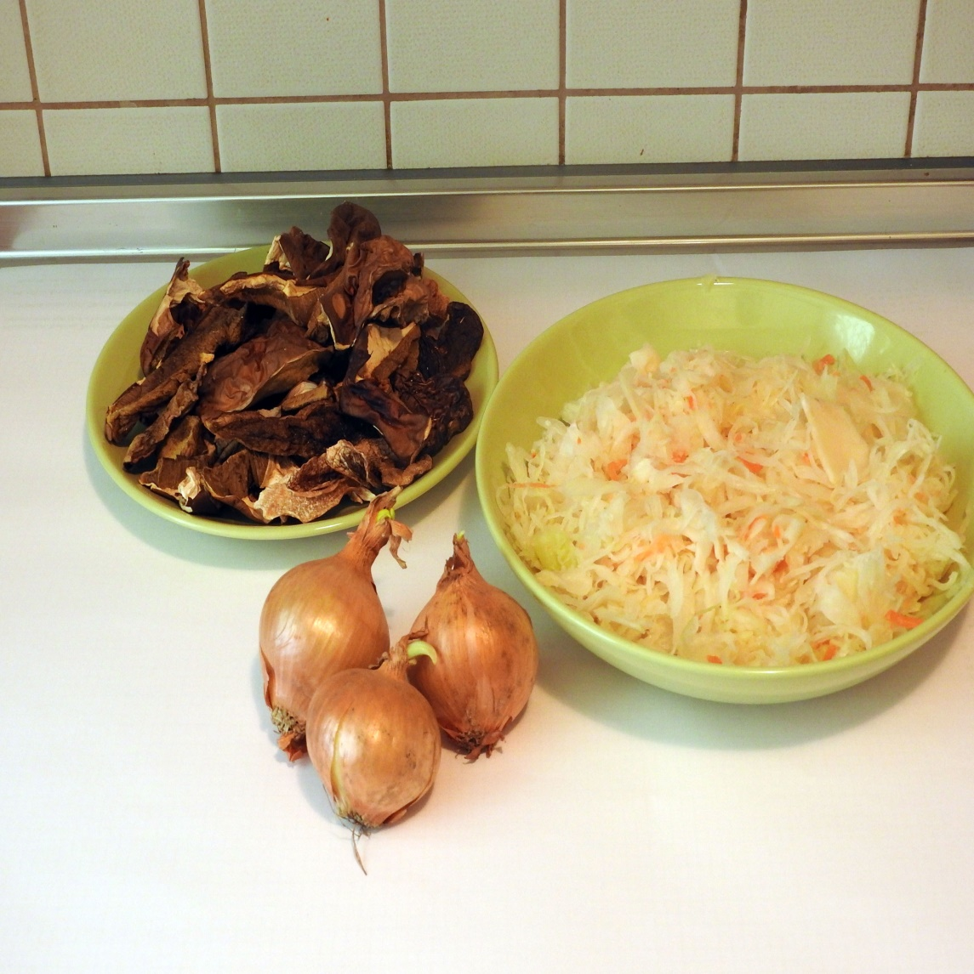 | 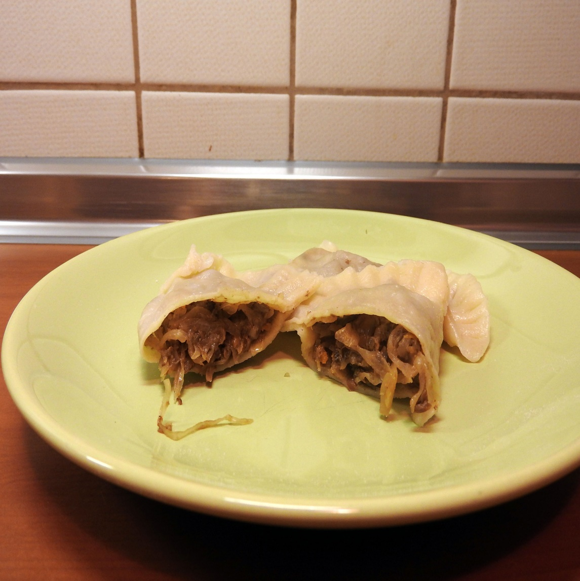

Recipe created by Asia Sobczak

Dumplings with sauerkraut and mushrooms
Dumplings with sauerkraut and mushrooms are one of the most traditional Polish dishes, which are served especially during Christmas season.  Preparation:  DOUGH:  mix all the ingredients and knead until you get dough.  STUFFING:  rinse the mushrooms, put them in cold water and wait 6 hours until they get soaked.  Then cook them, add peeled and chopped carrot and parsley. Cook together until they are tender. In the end add some salt and pepper.  Cook the sauerkraut until it gets tender, then drain it.  Take the mushrooms, carrot and parsley out of the water and drain. After that grind it with the sauerkraut.  Fry chopped onion on the frying pan. Finally, add it to the rest of the mixutre. Mix it all well, add some salt and pepper.  With the glass cut the circles out of the dough. In the middle put some stuffing with the use of a teaspoon. Then fold the dumplings in halves and stick the edges.  In a big pot boil some water with a pinch of salt and some oil. Bring it to the boiling point and put the dumplings inside. After they come out to the surface take them out, drain and put them on the plate.  time KCal People Style Type Level Cost  6 hours + 1 hour 171 kcal 10 other starter easy cheap | Ingredients:  DOUGH:  300 grams of wheat flour  pinch of salt  200 ml of hot water  30 grams of butter  STUFFING:  1 jar of dried mushrooms  kilo of sauerkraut  1 carrot  1 parsley  salt and pepper  3 spoons of oil  3 onions  History:  Dumplings are a traditional Polish dish. They arrived in Poland in the 13th century. They were brought to Poland by a monk, Jacek Odrowąż, from Kiev.  Tips:  To get more healthy effect we can use wholemeal or wholewheat flour. Or we can mix different kinds of flour.  To get more healthy effect we can use wholemeal or wholewheat flour. Or we can mix different kinds of flour.

Sopa de ajo
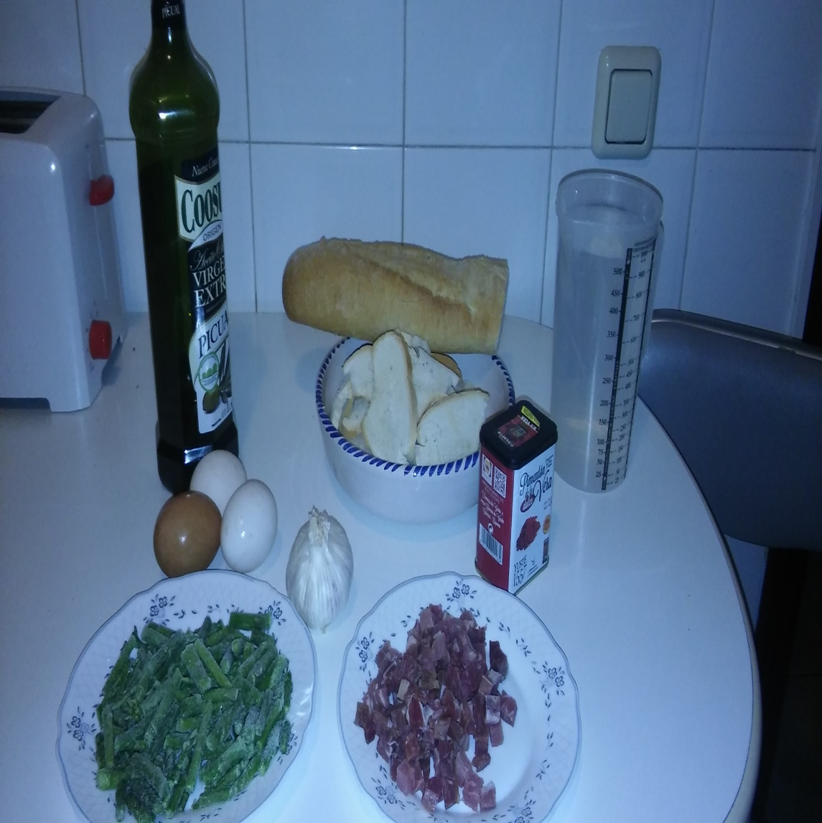 | 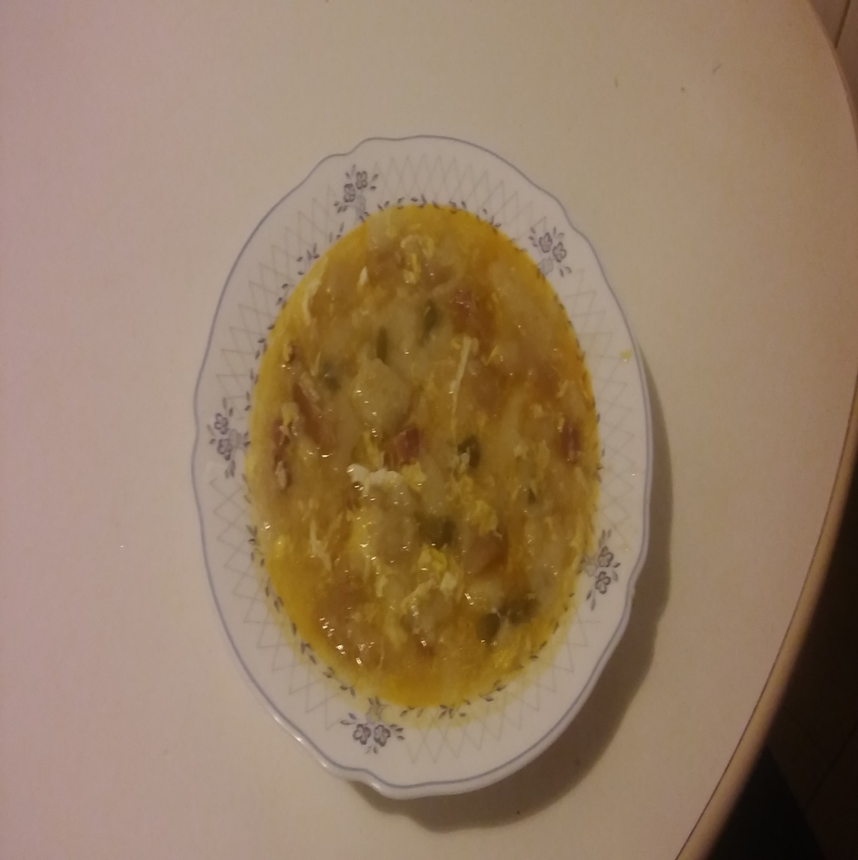

Recipe created by Jorge Morales Martin

Garlic soup
Garlic soup, or Castilian soup has been invented a long time ago and can be called the most basic soup in the world. It is made with leftover bread from the previous day, in addition to water, salt, oil and garlic. In Castilla y Leon, people also add peppers.  Preparation:  1. Peel the garlic and cut it into thin slices.  2. Mashed garlic is added before the oil is very hot, and fry it (be careful not to burn it)  3. Add dices of ham, the asparagus and bread  4. Add the peppers  5. We stir the ingredients  6. Add water and salt  7. Heat it up for 15 minutes  8. Break the eggs  9. Add the eggs to the soup  10. Stir the soup and enjoy  time KCal People Style Type Level Cost  30 min 535 4 fish starter easy cheap | Ingredients:  - 10 cloves of garlic  - 200 grams of bread  - 3 eggs  - 80 ml olive oil  - 1 teaspoon paprika  - 1/2 l water

Strammer Max
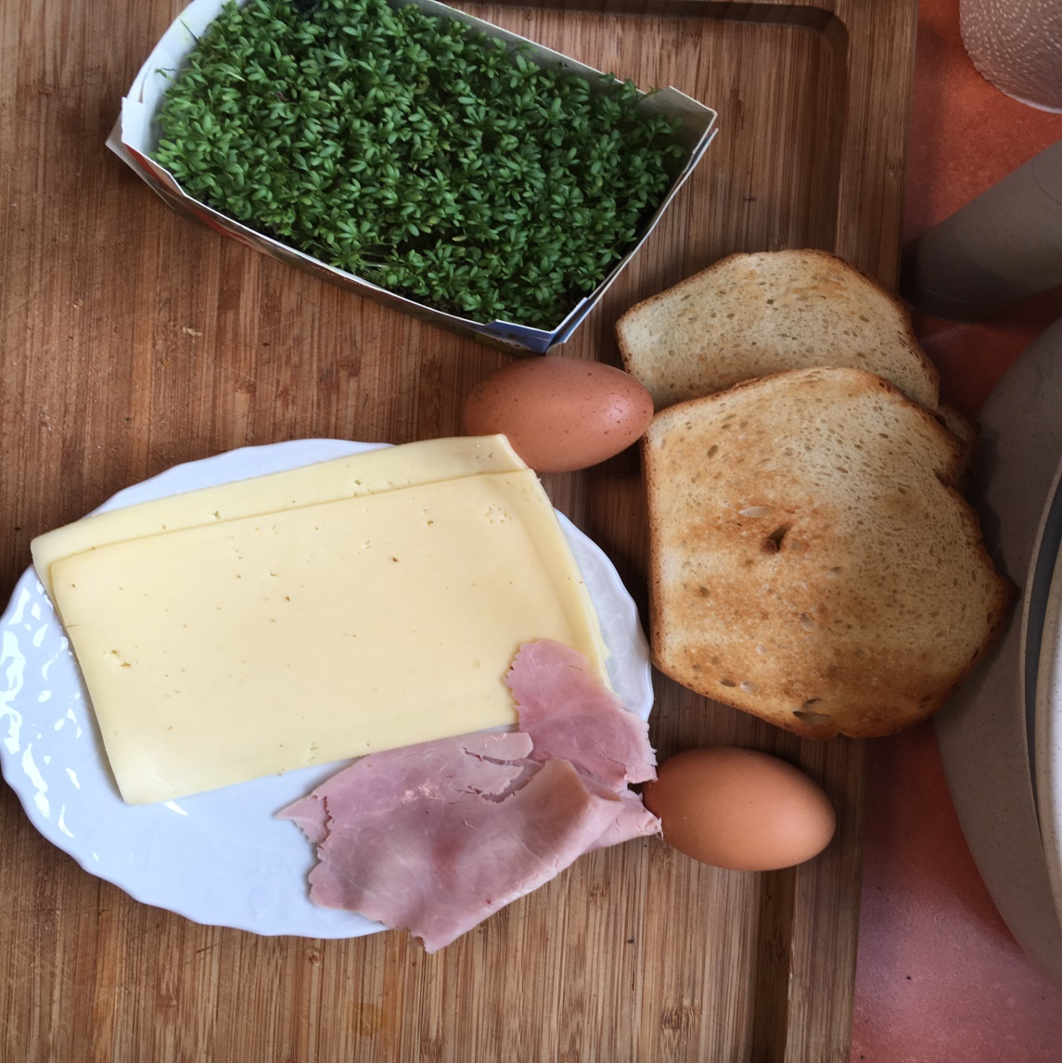 | 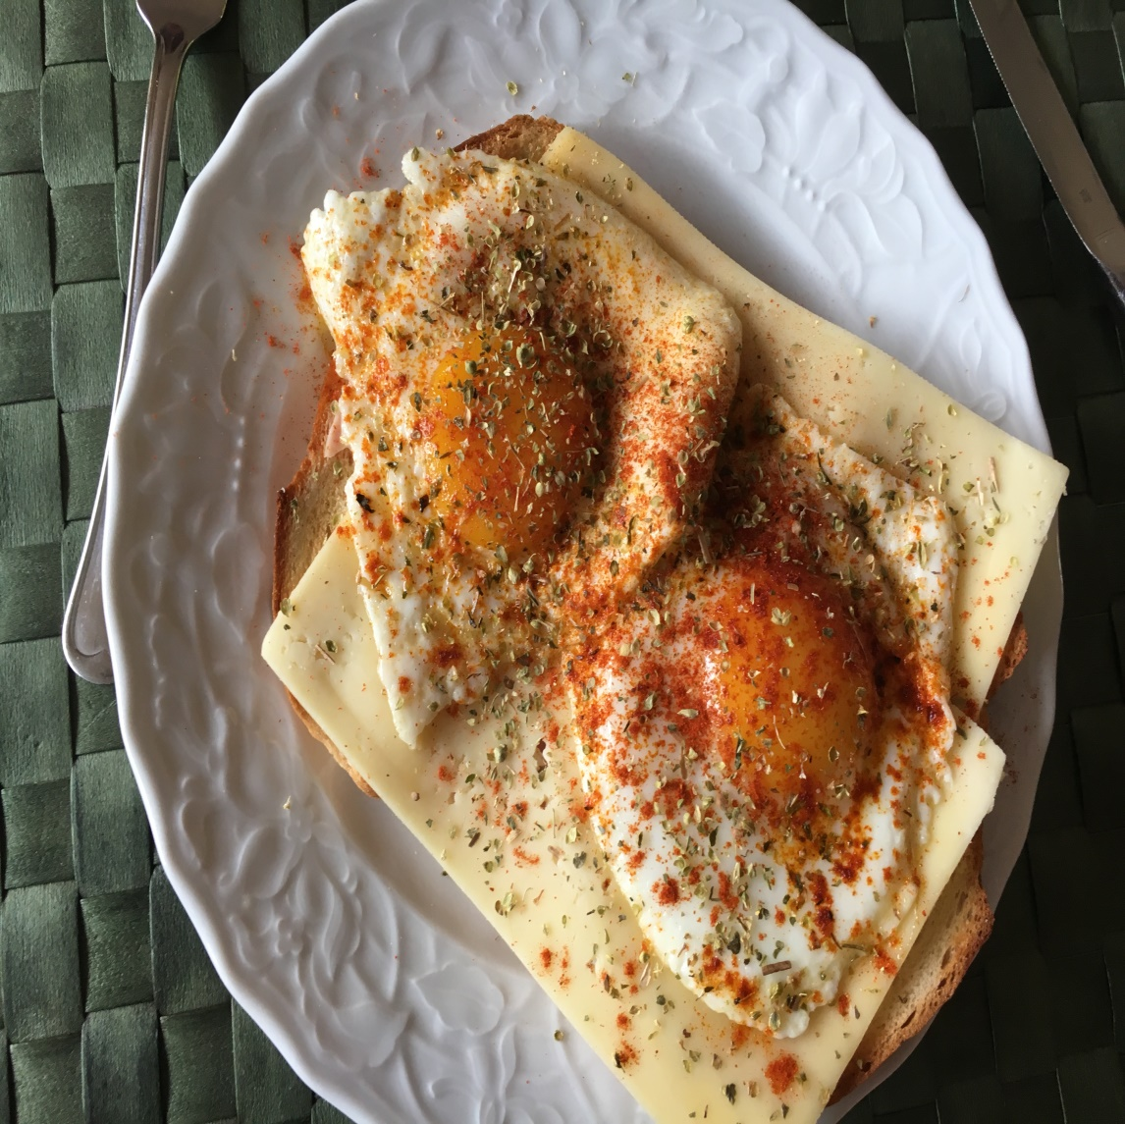

Recipe created by Leon Michels

ham and fried eggs on toast -- taut Max
The taut Max is a typical Rhenish recipe which is served most often for the breakfast.  Preparation:  1. The slices of bread coat with butter and book with cooked ham and cheese.  2. Heat up the oil in a frying pan and successively roast the fried eggs. With salt and pepper spice. The fried eggs hotly on the ham discs and the cheese disc lay.  3. Wash the chives, shake drily and in little role cut. The taut Max garnish with little chives role and immediately serve.  time KCal People Style Type Level Cost  10 min 650 1 other starter easy cheap | Ingredients:  1 disc of coarse rye bread  10 g of butter  1 disc of cooked ham  1/8 alliances chives  1/2 tablespoons of oil  2 eggs  Salt  Pepper  History:  Grandma did it every Sunday.  Tips:  If one serves it with chives or inlaid cucumbers, this provides for a nicer sight of the recipe.

Zupa krem pieczarkowa
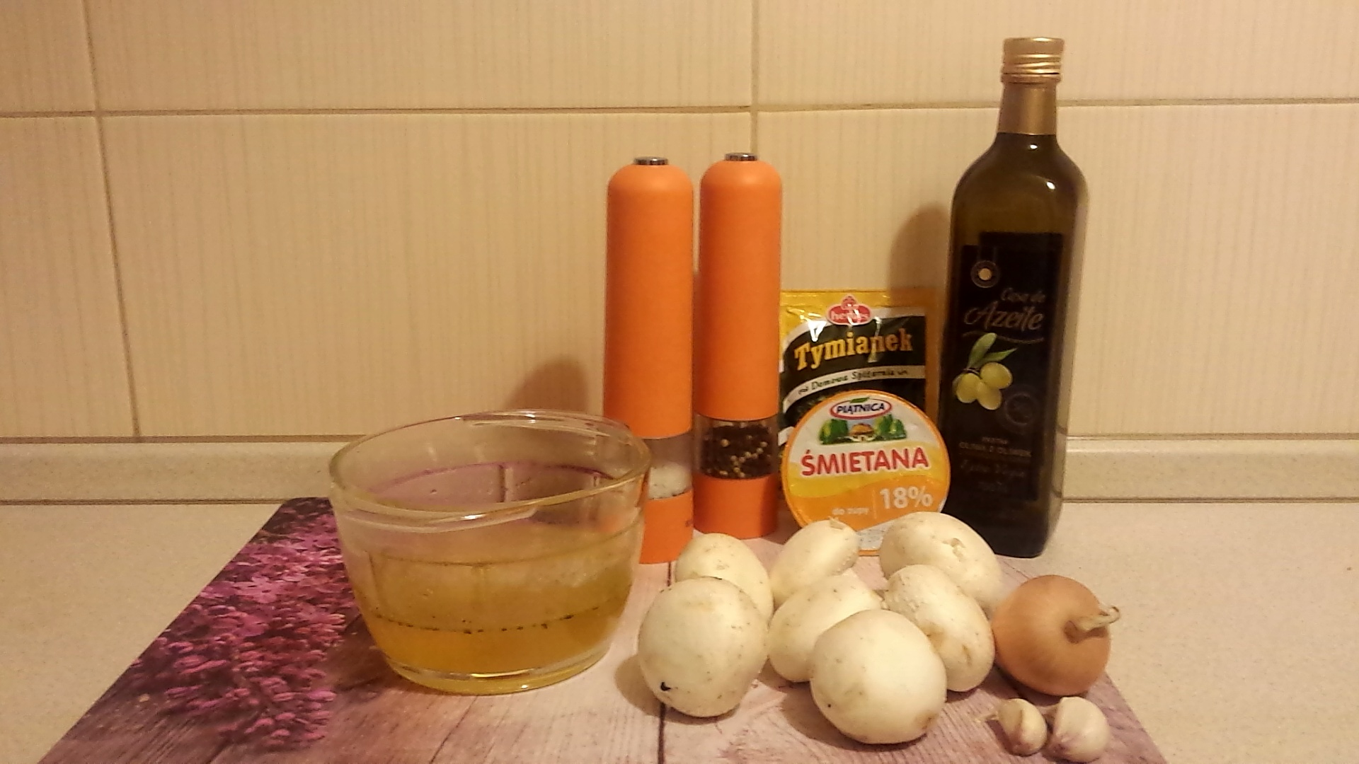 | 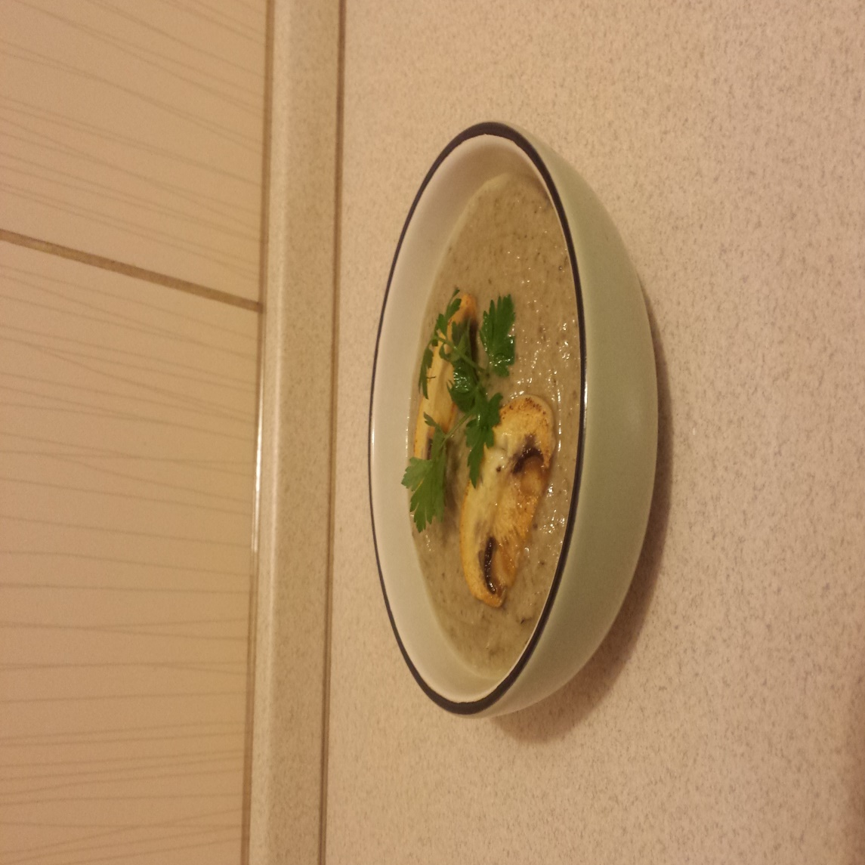

Recipe created by Kaja

Mushroom soup
Preparation time : 30 minutes Number of portions : 3-4  Preparation:  Slice the mushrooms finely. Heat a large saucepan over a medium heat and pour in a splash of olive oil. Add the onion, celery, garlic, parsley stalks, thyme leaves and mushrooms, place a lid on top and sweat gently until softened. Spoon 4 tablespoons of mushrooms out of the pan and put to one side. Pour the stock into the pan and bring to the boil. Turn the heat down and simmer for 15 minutes. Season with salt and pepper, then whiz with a hand-held blender until smooth. Pour in the cream, bring just back to the boil, then turn off the heat.  time KCal People Style Type Level Cost  30 4 soup starter easy cheap | Ingredients:  1 onion , peeled and finely sliced  2 sticks celery , trimmed and finely sliced  3 cloves garlic , peeled and sliced  a few sprigs of fresh flat-leaf parsley  a few sprigs of fresh thyme  1.5 litres organic chicken or vegetable stock  sea salt  black pepper  75 ml single cream  4-6 slices ciabatta bread  Tips:  Garnish with the chopped parsley and remaining mushrooms, and serve with the ciabatta crostini.

Śledź w oleju
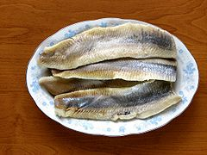 | 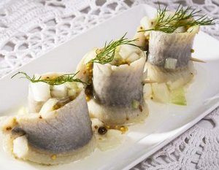

Recipe created by Dominik Komarnicki

Oil Herrings
Oil herrings are popular polish starter. They are served as one of 12 Christmas dishes.  Preparation:  Put herrings into the bowl of water, change water 4 times every 30 minutes (U can add some milk).  When herrings are soft cut them as u want and put into the jar.  Slice onion into the little dice and put into the jar.  Slice lemon and put 2/3 slices into the jar.  Pour oil on everything.  time KCal People Style Type Level Cost  15 minutes 200 kcal/100g 5 fish starter easy cheap | Ingredients:  5 herrings for one jar  one lemon  2 onions  oil  optionally 1 glass of milk  History:  I know that recipe from my dead grandpa who has always prepared oil herrings on family meetings.  Tips:  You can decorate them with parsley.  You can decorate them with parsley.

Ensalada de pasta
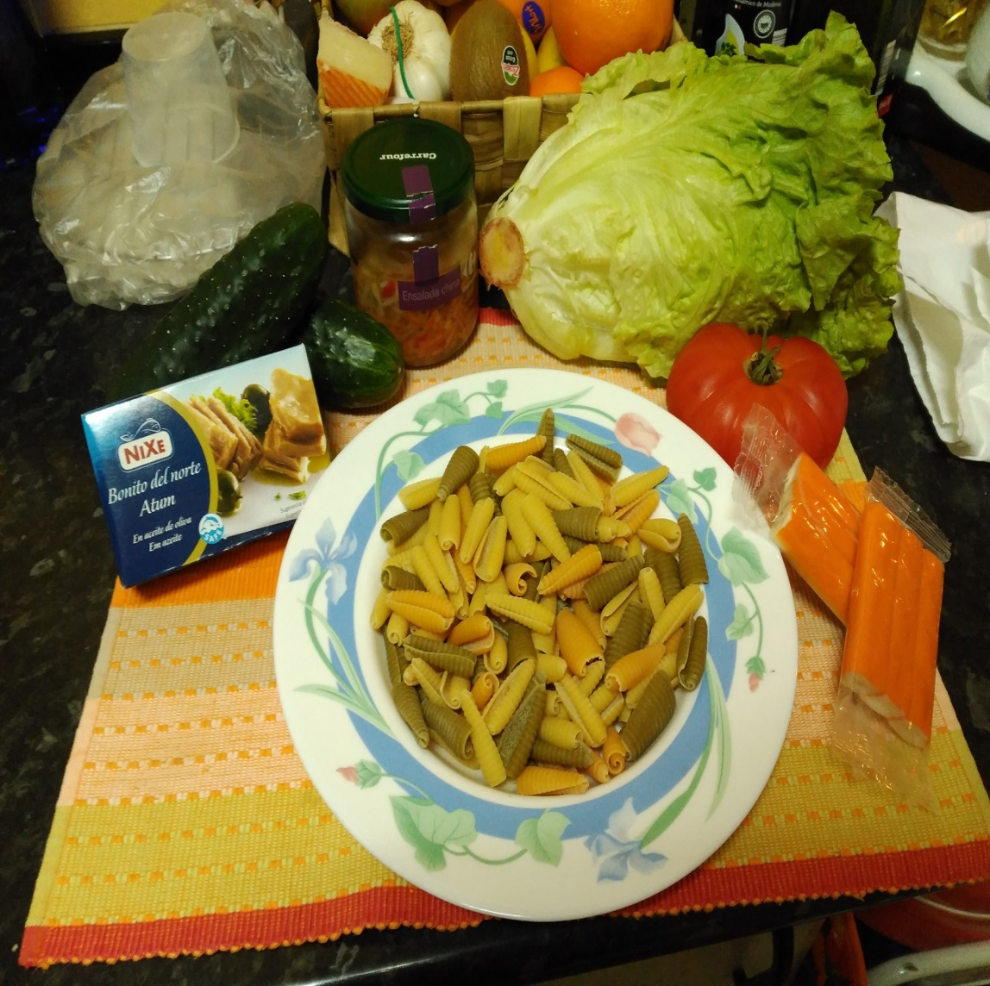 | 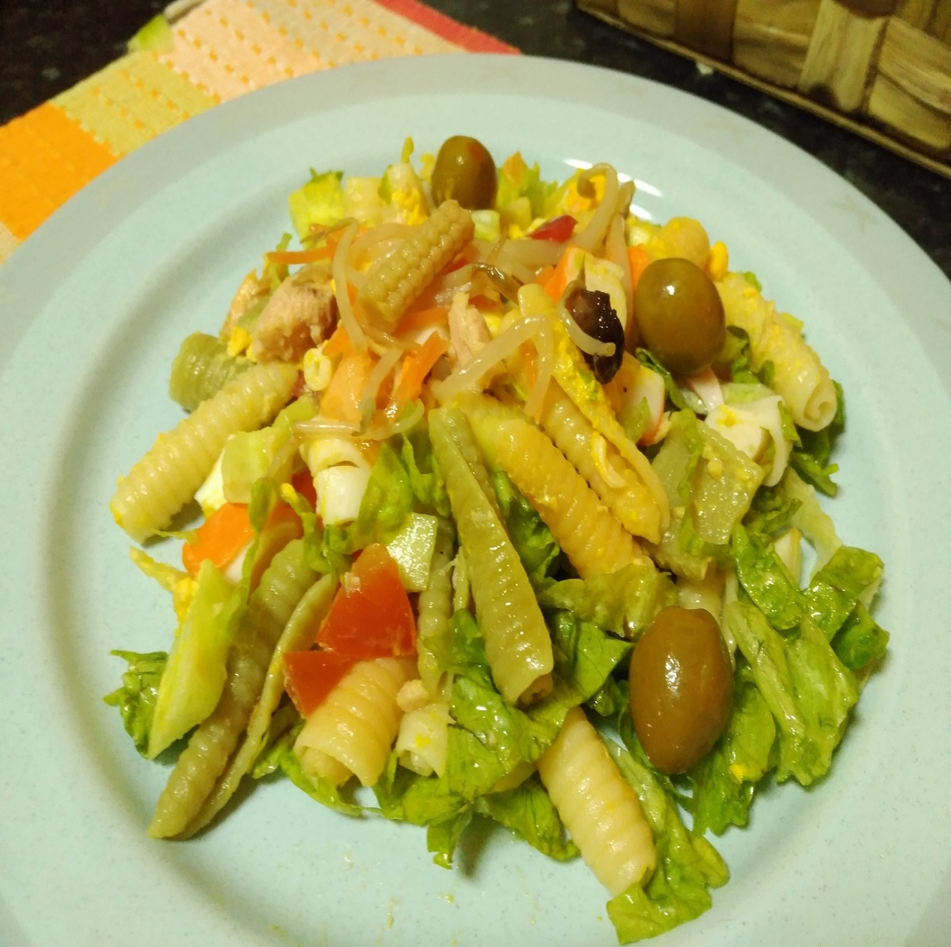

Recipe created by Bruno Rojas Piñero

Pasta Salad
It is a cold salad with pasta  Preparation:  We prepare the ingredients we are needing. We cook the pasta and the eggs for unlist 8min, We stir the pasta to no stay stuck. We cut the rest of the ingredients, we mix them and we add tuna, eggs and pasta.  To end we put the food on the dish and we add olives and teh beandsprouts.  time KCal People Style Type Level Cost  15min 630 2 salad starter easy cheap | Ingredients:  pasta  tomato  cucumber  tuna  egg  crab sticks  Tips:  It is eaten cool. You can add it salad cream or olive oil , vinegar and salt  It is eaten cool. You can add it salad cream or olive oil , vinegar and salt

Kartoffelsuppe
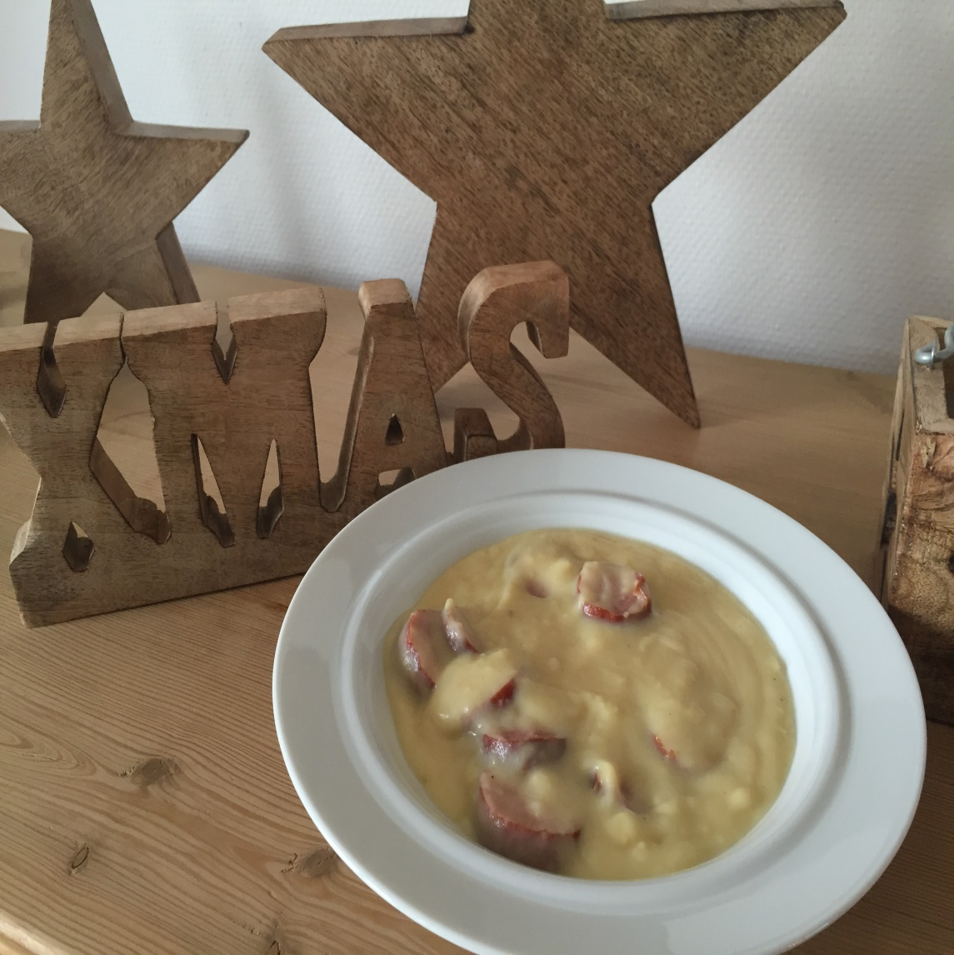

Recipe created by Anne Hamacher

Potato soup
Delicious soup, especially during Christmas time.  Preparation:  1. Put 1 spoon olive oil into the pot.  2. Cut the onion into small pieces and braise it slightly on a low heat.  3. Cut the peeled potatoes, carrots, leek and parsley root and add them to the pot.  4. Add the stock and boil everything. (approx. 25 minutes -> potatoes should be fully cooked)  5. Mash everything.  6. Add the cream.  7. If necessary add salt, pepper and nutmeg.  time KCal People Style Type Level Cost  40 - 45 minutes 65 kcal per 100 ml 3-4 soup starter medium cheap | Ingredients:  500g potatoes  1 onion  2 carrots  1 leek  1 parsley root  750 ml clear soup  250 ml cream  nutmeg  Salt and pepper

Pisto manchego
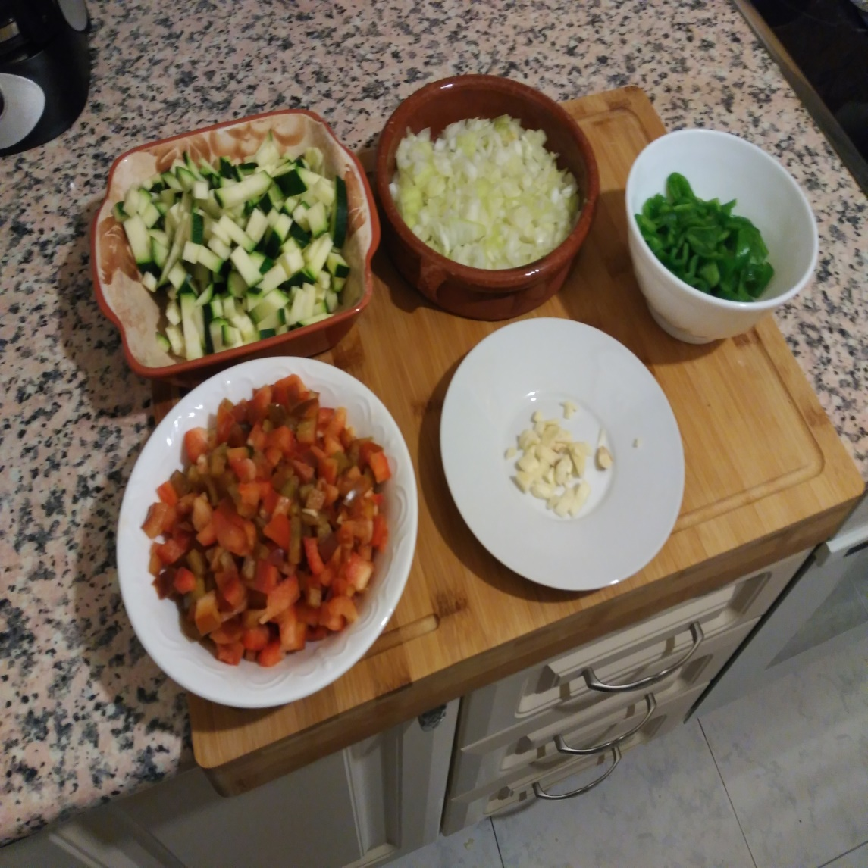 | 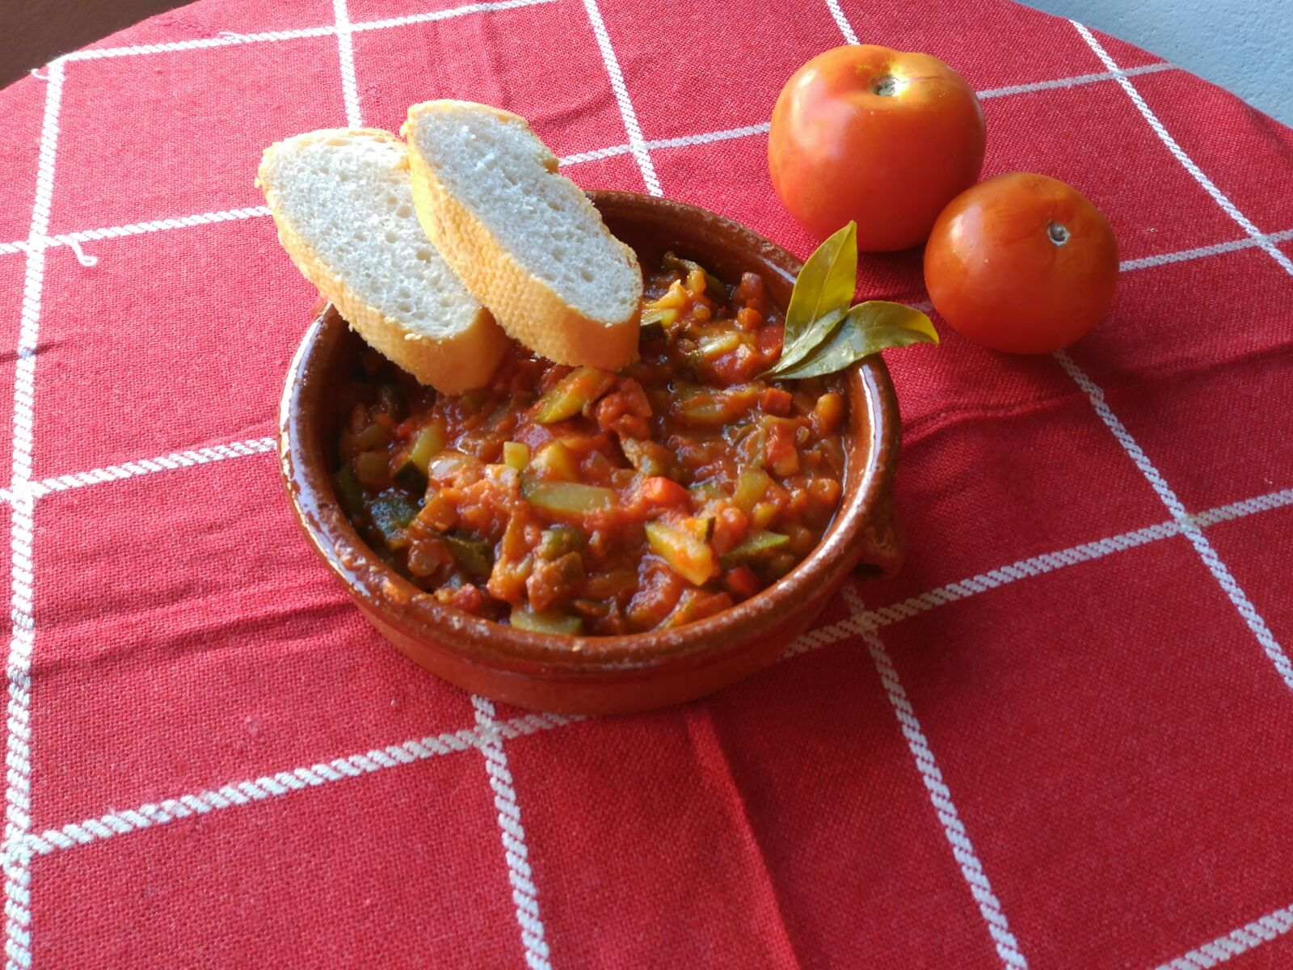

Recipe created by Mariam Andrino Lahlou

Ratatouille’s of La Mancha
Ratatouille of la Mancha is a traditional dish of Spanish food that consists of a fry of several vegetables (usually red pepper, green pepper, onion, garlic, tomato and zucchini but the récipe can vary). The nickname “La Mancha” comes from its origins but this dish is popular over almost the entire Spanish territory.  time KCal People Style Type Level Cost  30min 121 4 vegetable starter easy cheap | Ingredients:  • A zucchini  • An onion  • A couple of garlic cloves  • A red pepper  • A green pepper  • 250 grams of crushed tomatoes  • Virgin olive oil  • Salt  History:  Originally, this dish was cooked by the peasants of La Mancha with garden products, which were very accesible. The authentic ratatouille only has green and red peppers, tomatoes and zucchini, but the vegetables used often vary depending on the area, season and local tastes.  Tips:  It is usually served as a starter but if you add more ingredients such as meat, it can be considered main course. It is common to eat it with a fried or poached egg but it is optional. It is recommended to eat with bread to dip it in the tomato sauce.  It is usually served as a starter but if you add more ingredients such as meat, it can be considered main course. It is common to eat it with a fried or poached egg but it is optional. It is recommended to eat with bread to dip it in the tomato sauce.

Ensalada de pimientos rojos
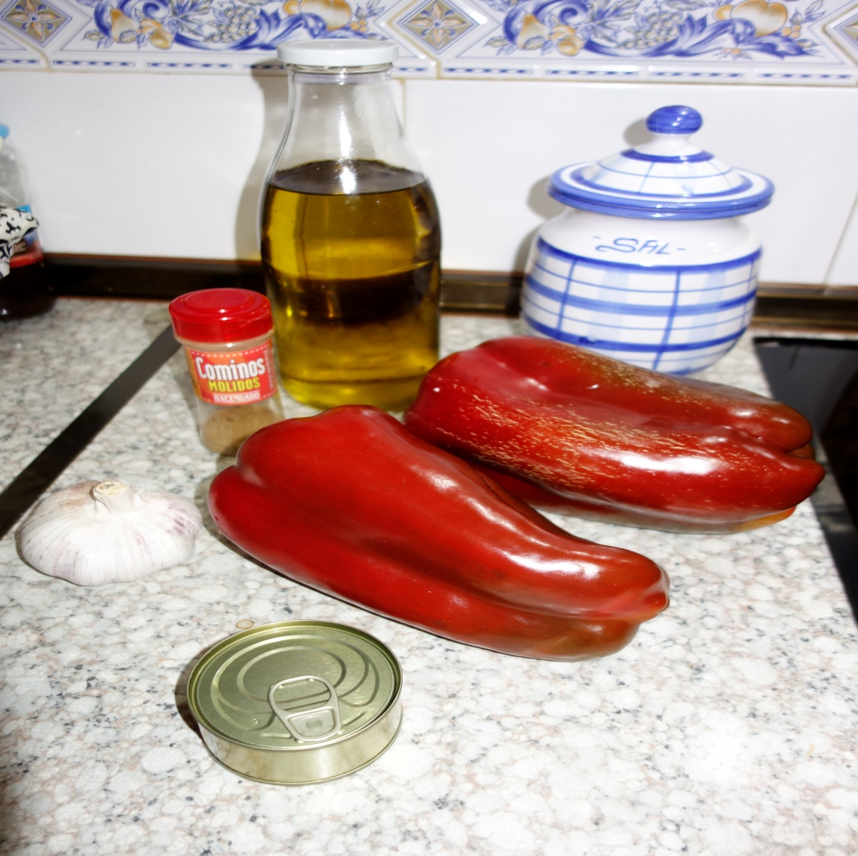 | 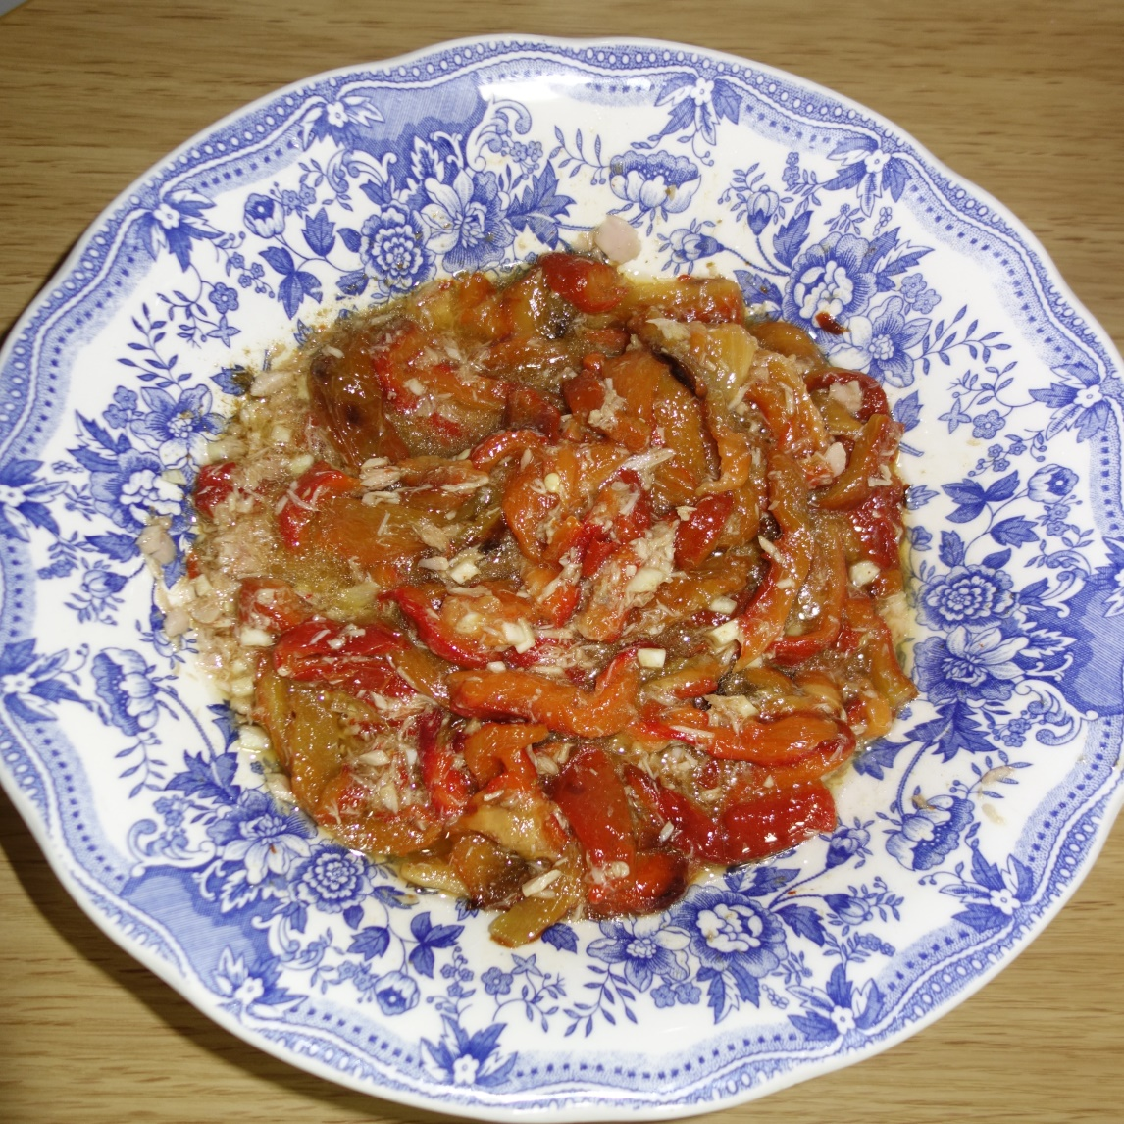

Recipe created by Ana and Diego Rodríguez Sánchez

Red Peppers salad
The red pepper said is a salad that we can consume in all the seasons of the year. We serve this plate like a main course or like garniture.  Preparation:  1. On the first hand we put the red peppers in a flat braking tray and we put it into the oven to two hundreds degrees durimg twenty minutes.  2. On the second hand we cut in small pieces the garlics and e tip out the tuna.  3. Then, when the peppers are cokeed we peel it with our hunds.  4. We mix the peppers with the pieces of garlic, the tuna, and we add cumin, oil, and salt.  time KCal People Style Type Level Cost  1 hour 2000 3 vegetable starter medium medium | Ingredients:  2 red peppers  Cumin  Oil  Salt  Tuna fish  Two garlic cloves  History:  This salad began to prepare to eating in the summer days. It began to eating in small towns of Aragón and Cádiz.  Tips:  This salad is eaten cold, and we can add it asparagus, boiled eggs, or olives.  This salad is eaten cold, and we can add it asparagus, boiled eggs, or olives.

Pierogi Ruskie
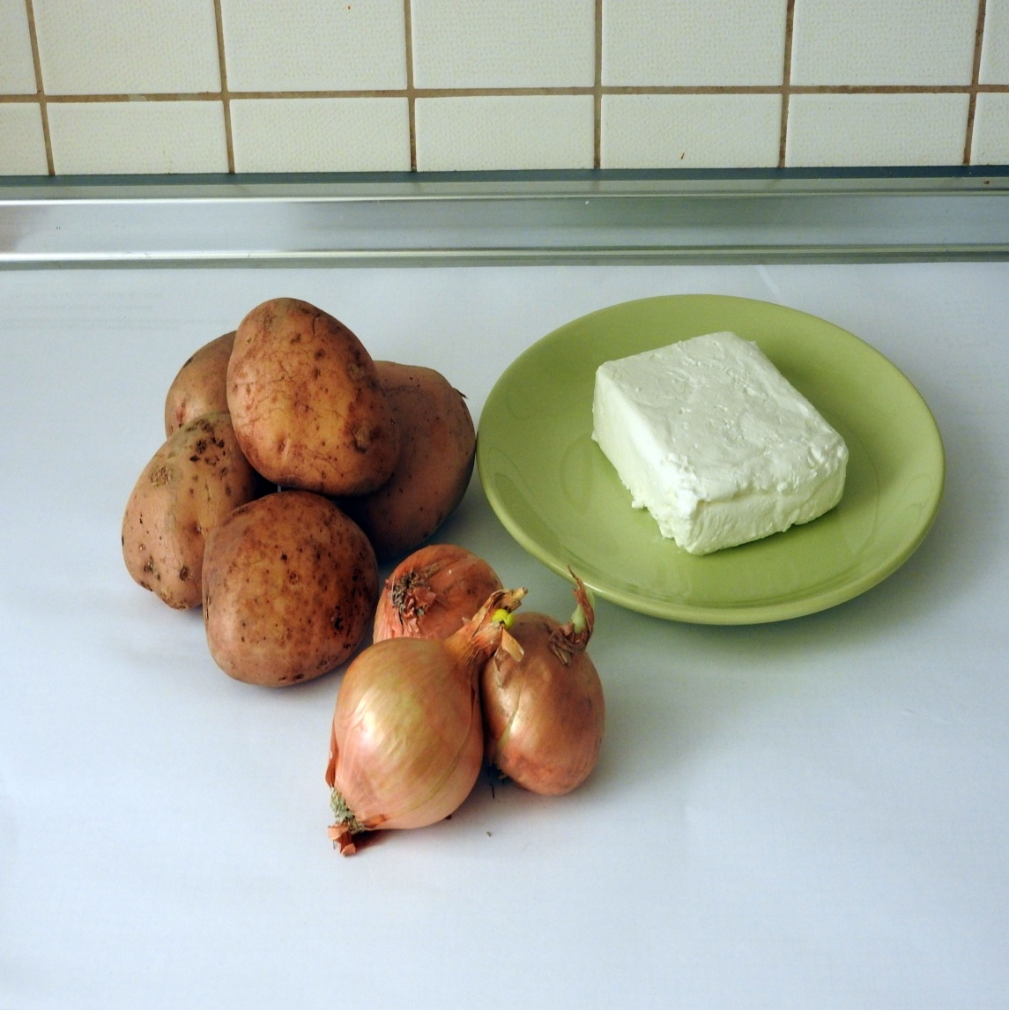 | 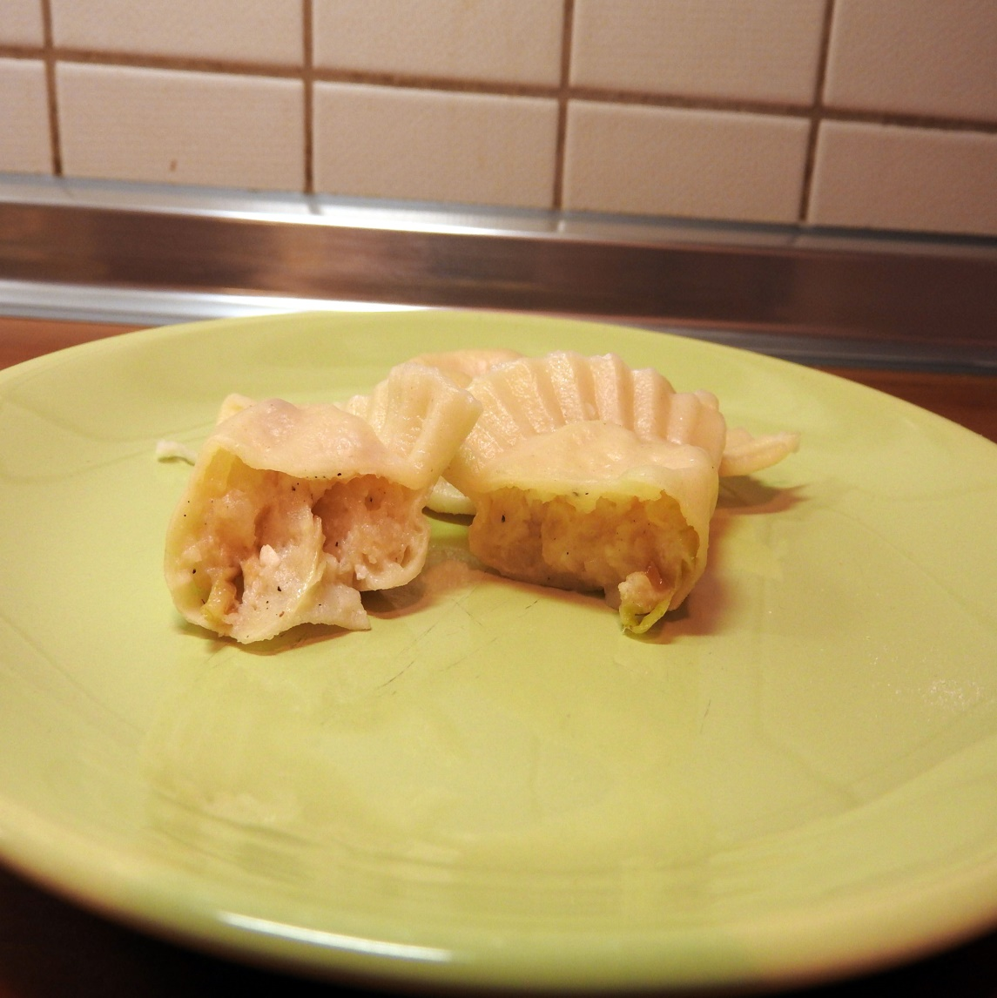

Recipe created by Asia Sobczak

Russian Dumplings
Russian Dumplings is one of the most traditional Polish dish, which might be served both as a starter and as a main course. It is the dish which used to be the most popular dinner dishes in Polish families.  Preparation:  DOUGH: Put together all the ingredients and knead until the dough is ready.  STUFFING:  1) Peel the potatoes, rinse, insert into the pot with cold water, add salt and bring to the boiling point. Cook for about half an hour until it gets tender.  Drain, put back into the pot and whip. Wait until the potatoes cool down.  2) Crumble cheese, mash with the fork, mix with the potatoes, add salt and pepper. Cut onion into cubes and fry in butter. Add to the stuffing and stir all ingredients.  3) Use the glass to cut the circles out of the dough and put the stuffing in the middle using a teaspoon. Fold the dumplings in halves and put the edges together. Put the dumplings on the table.  4). Biol salted water in a big pot, add a spoon of oil. Bring it to the boiling point and put the dumplings in water. When they come to the surface, boil them for 2 more minutes. Take them out, drain and put in on the plate.  time KCal People Style Type Level Cost  1 hour 218 kcal 10 other starter easy cheap | Ingredients:  DOUGH:  300 g flour  pinch of salt  200 ml of hot water  30 g of butter  STUFFING:  500 g of fat or vanishing cottage cheese  500 g of potatoes  2 teaspoons of salt  1/2 teaspoon of ground pepper  1 small onion  2 spoons of butter to fry onion  History:  Dumplings are a traditional Polish dish, but it arrived in Poland with the monk Jacek Odrowąż in the 13th century. He brought them from Kiev, the former region of Russia.  Tips:  To get more healthy effect you can use wholemeal or wholewheat flour, or you can mix different kinds of flour.  To get more healthy effect you can use wholemeal or wholewheat flour, or you can mix different kinds of flour.

Bigos z grzybami i mięsem
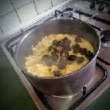 | 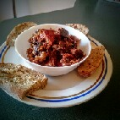

Recipe created by Mateusz Lubomski

Sauerkraut stew with mushrooms and meat
Famous Polish dish of sauerkraut with mushrooms and meat. Popular on Polish tables at Christmas.  Preparation:  Rinse the cabbage, get rid of excess water and finely chop.  Chopped cabbage put into a large pot and pour hot water. Add the plums, allspice and bay leaves. Whole mix and boil for about 60 min. During cooking, prepare the dried mushrooms and the rest of the ingredients. Pour hot water on mushrooms and cover them. Cut the onion and sausage then fry them for a while. Cut other meat and put them into boiling water for 20 min. Cut mushrooms and add them to cabbage with meat and onions. All carefully mix and cook about 30 min. Spice for your taste and add the tomato paste. The whole cook for another 20 minutes.  time KCal People Style Type Level Cost  3h 130 4 other starter medium medium | Ingredients:  2 kg of sauerkraut  2 onions  oil  250 g sausage  250 g boneless beef  250 g pork shoulder boneless  100 g bacon  4 tablespoons tomato paste  0.5 handfuls of dried mushrooms  0.5 handfuls of dried plums  3 bay leaves  4 English herb  1 tablespoon cumin  1 tablespoon marjoram  salt pepper  History:  Sauerkraut stew is extremely mysterious dish, because it was not preserved any old recipe for this traditional Polish dish. Everything points so that the precise instructions of preparing the stew were passed from mouth to mouth and because of the huge popularity of his, no one thought about it, to save the recipe, because everyone knew just how to cook stew.  In addition to the enormous popularity of this culinary works in Polish, in distant times he characterized him even more of its practicality. Sauerkraut stew was perfectly suited to the dish being eatables for long journeys. Due to the fact that its primary ingredient is sauerkraut, so do not spoil too quickly, and by repeatedly reheating adds more flavor and are not recognized as it might seem. Sauerkraut stew given in many ways, as a hot breakfast, especially just for those who journey leaving, as well as a first course, after dilution with water eaten it in their homes as a traditional Polish soup.  Tips:  You can add some honey for taste.  You can add some honey for taste.

Remojón
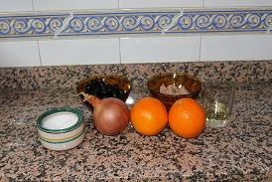 | 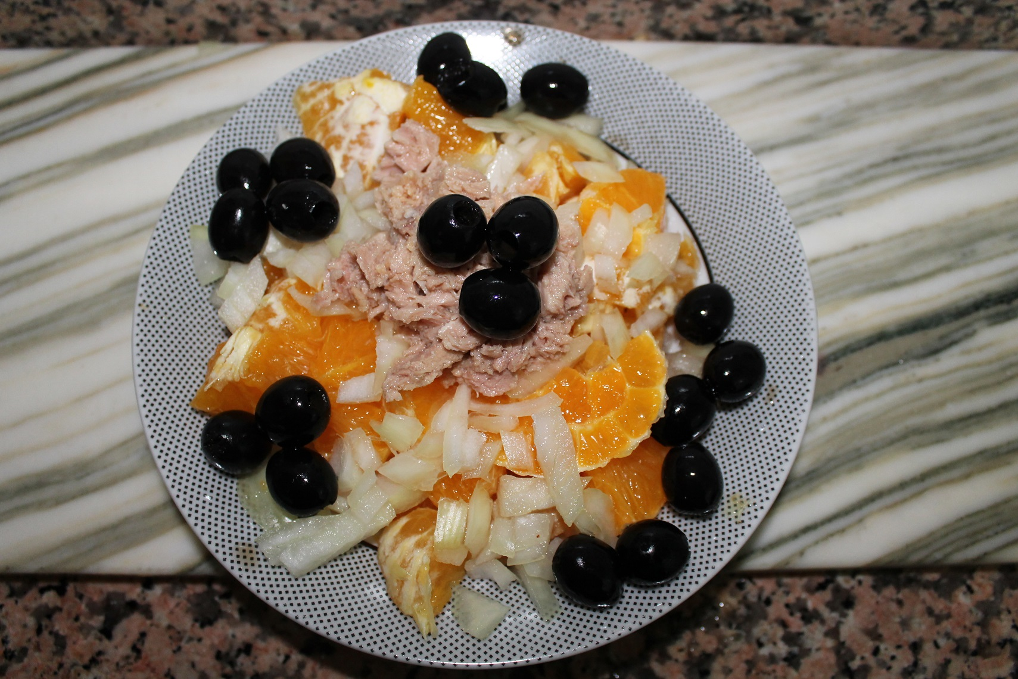

Recipe created by Ángela García Fernández

Spanish salad "Remojón"
Remojón is a tipycal Andalusian salad whit orange, onion, tuna in olive oil or roasted cod and olives.  Preparation:  First peel the oranges and the onion. Then chop the oranges and the onion in small cubes, next put them in a plate, add olive oil, tuna in olive oil or roasted cod and finally add the olives.  time KCal People Style Type Level Cost  15 minutes 533 2-3 vegetable starter easy cheap | Ingredients:  2 oranges  ½ onion  olives  2 soup spoons of olive oil  50-70 gr of roasted cod or tuna in olive oil  History:  "Remojón" is a tipycal Andalusian salad that people commonly eat in summer

Tofu à la ryba po grecku

Recipe created by Adam Kanafa

Tofu ala greek fish
Greek fish is one of Chrismas dishes.This is vegetarian form.  Preparation:  Cut tofu for the slices, then add salt, pepper sweet pepper and all the slices pour with soja sauce.Leave it for 10-15 min. Next coat with flour and fried on hot oil to brown. Prepareing vegetables: cut leek for the slices and then fried on oil with spices. In the meanwhile wipe off on the rasper and add this to leek. Pour more water. When vegetables will be soft, add a tomato sauce. Cook on free fire 5-10 min. Tofu put on the plate. Then the vegetables,on the top pour some lemon.  time KCal People Style Type Level Cost  30-40 min ~500 3-4 vegetable starter medium cheap | Ingredients:  1 block of tofu (180g)  5 carrots  1 leek  2 small parsley  1 small celery  1 tomato sauce  Water,oil, spices, (pepper, salt, sweet paprika, allspice,bay leaf,soja sauce,white sugar)  1 lemon  History:  This recipe i know from my mom,and she is a vegetarian and she always do it during Christmas.  Tips:  U can decorate this dishes with slices of lemon and a sprig of parsley.  U can decorate this dishes with slices of lemon and a sprig of parsley.

Sałatka z tuńczyka
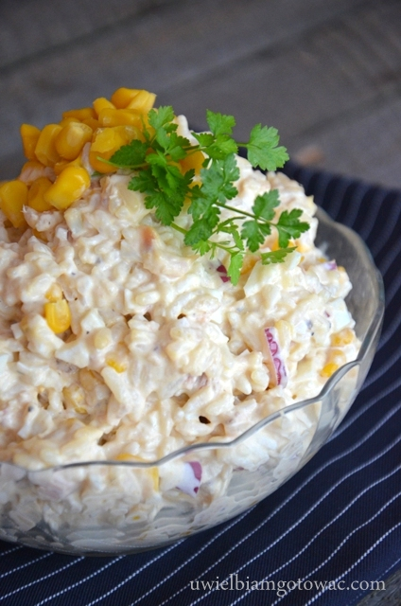 | 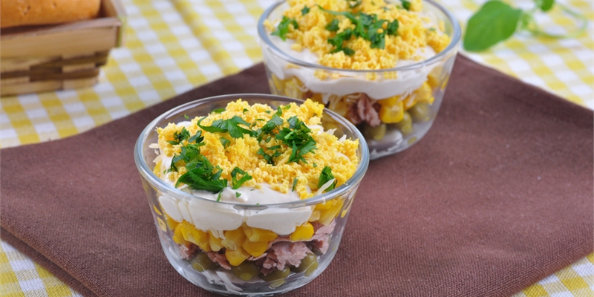

Recipe created by Kaja

Tuna salad
Tuna salad is a very healthy,light and tasty dish. Actually, tuna has a perfect influence on our health, well-being and strength. We often prepare this salad as an addition to our family dinners.  Preparation:  Pour off the oil from the tuna can and divide it into smaller parts. Drain the corn, because it may contain some water. Dice the pickles and the onion. Mix all the ingredients, add mayonnaise, salt and pepper. Stir it all at the end.  Bon Apetit!  time KCal People Style Type Level Cost  20 173 3 fish starter easy cheap | Ingredients:  1 can tuna in oil  1 can of corn  25 g of pickles (3-4 pieces)  1 onion  mayonnaise  salt  pepper  History:  This recipe goes on from generation to generation in my family. My grandfather started this custom, because he was a sailor and he used to bring fish from his long journeys.  Tips:  Serve with bread. Do it up with herbs.  Serve with bread. Do it up with herbs.

Überbackene Mettbrötchen
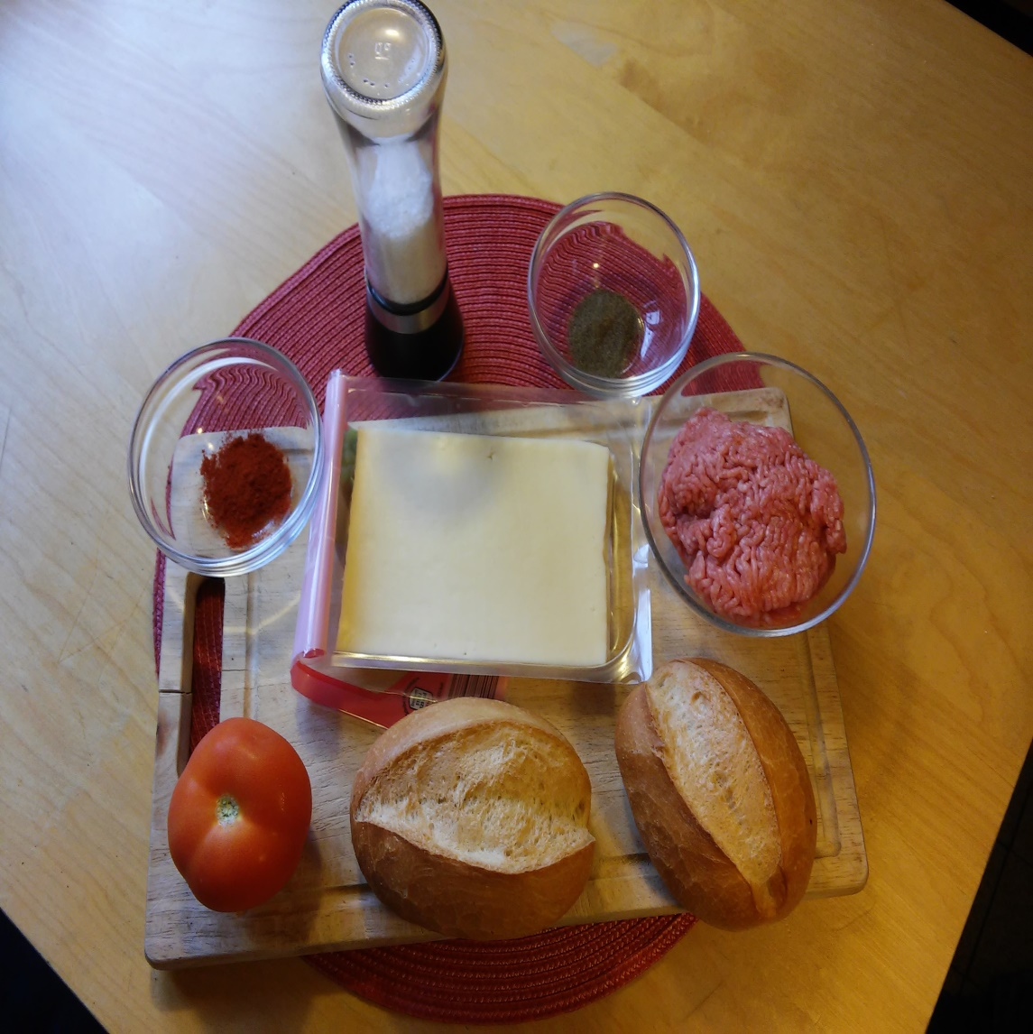 | 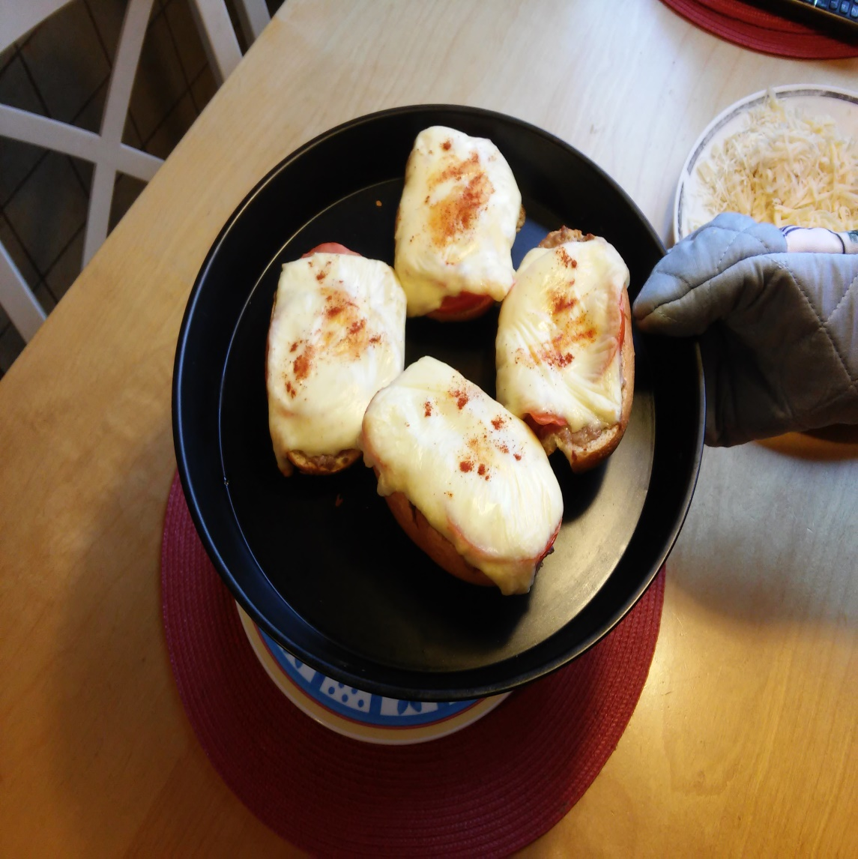

Recipe created by Charalampos Michailidis (Harry

Baked Bread rolls with Ground pork
As the name implies, bread rolls with ground pork are simply cut up bread rolls, smeared witch ground pork, quickly preparable at any time. There are many ways of making a ground pork bread roll and this recipe serves as a suggestion for cheese-lovers. Your creativity is set no bounds.  Preparation:  Cut the bread rolls along the sides and smear the ground pork (0,5cm thick) on them. Now cut the tomatoes into thin pieces and spread them out. Spice them up with a bit of salt and pepper. Afterwards, place around 1 to 1,5 sliced pieces of cheese on each piece of bread and sprinkle some paprika powder on them.  After everything is done, put the bread rolls into the oven and bake them for about 15 minutes with a temperature of about 180 – 200 °C.  time KCal People Style Type Level Cost  25 Minutes 1200 2 meat snack easy cheap | Ingredients:  250g ground pork  1,5 tomatoes  1 pack of sliced cheese  4 bread rolls  Salt and pepper  Paprika powder  History:  Because of their fast preparation time and the possibility of eating them raw, bread rolls with ground pork were a university students favourite snack in the 80s and 90s in Germany  Tips:  You can add and take away whatever you want, as long as you leave the bread rolls and ground pork.  You can create whatever you want!  You can add and take away whatever you want, as long as you leave the bread rolls and ground pork.  You can create whatever you want!

Weckmann
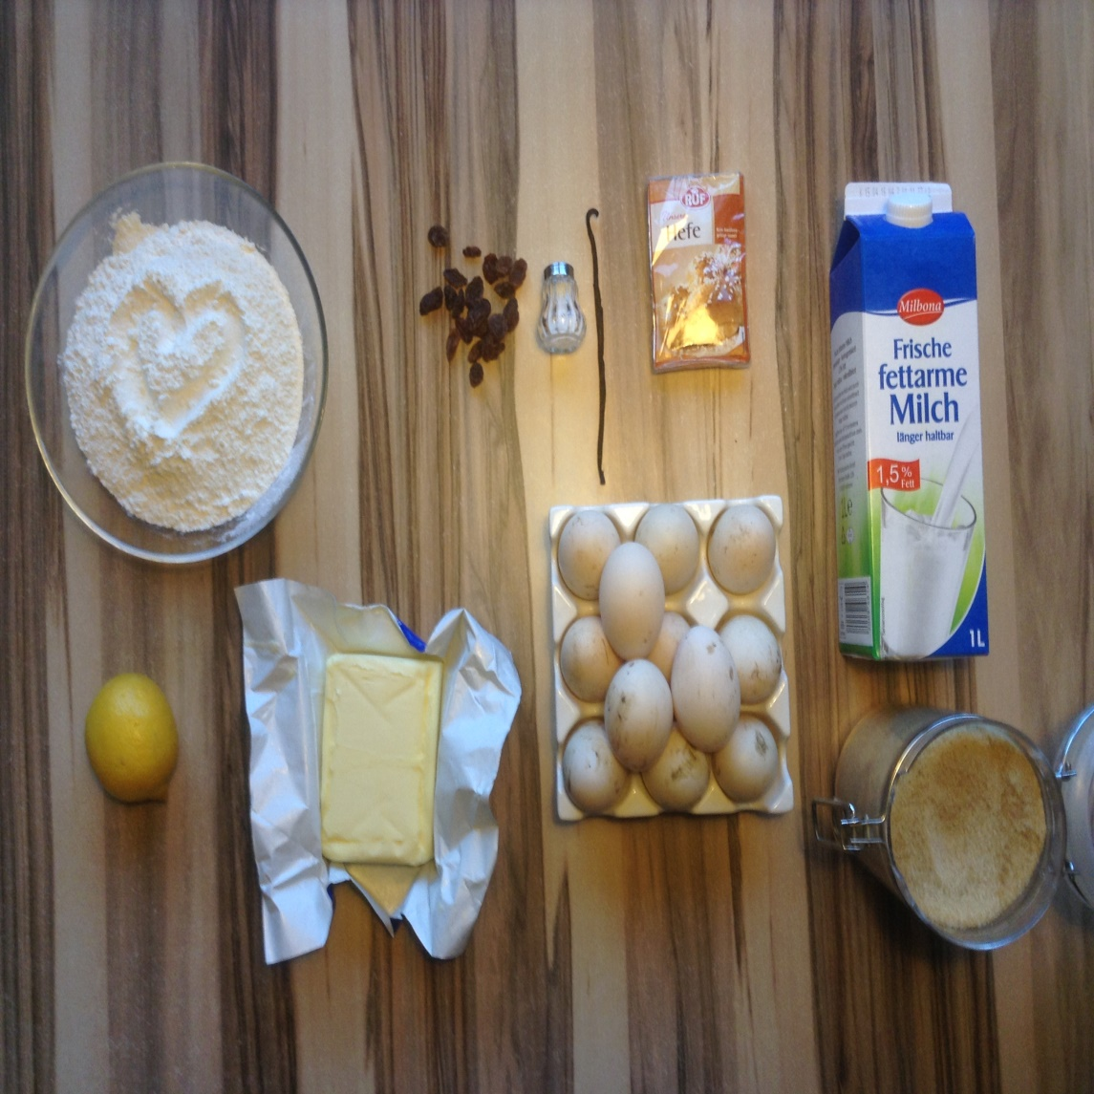

Recipe created by Pia Thiel

Breadman
Popular treat around christmas with a soft sweet yeast dough.  Preparation:  Put flour into a bowl and make a hole in the center. Mix the milk with the yeast and pour it into the hole. Gently mix it in with some of the flour scooped from the sides of the hole. Cover the bowl with a towel and keep it in a warm place for 15 minutes.  Add the rest of the ingredients and knead the dough until it is smooth. Let it sit again for 15 minutes.  Roll out the dough about 2,5x5 cm thick and cut out or shape into breadman.  Rub some beaten egg yolk onto the breadman to give it a nice shiny tint. Let it sit for another 15 minutes and rub on some egg yolk again. Bake it at 190 degrees Celsius for 10-15 minutes until it is brown.  time KCal People Style Type Level Cost  90 minutes 100 gr. 337 kcal / 1409 k other snack medium medium | Ingredients:  600 grams of flour  40 grams of fresh yeast  1 cup of lukewarm milk  2 eggs  65 grams of sugar  100 grams of melted butter  1 pinch of salt  grated lemon zest of one whole lemon  A touch of vanilla  Tips:  Cover the whole breadman with egg yolk to give it an evenlz brown crust.  Cover the whole breadman with egg yolk to give it an evenlz brown crust.

Bugne Lyonnaise
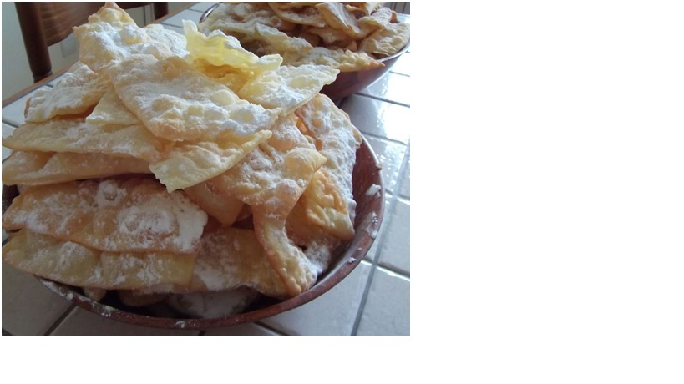

Recipe created by SINTES Honorine

Bugne Lyonnaise
Preparation time: 20 minutes Cooking time: 20 minutes (serves 4)  Preparation:  Work all the ingredients to a smooth dough. Let rest 1 hour. Expand out the dough and cut the dough into rectangles need to be expand to get the dough as thin as possible. Fry in a pan with oil. Let brown, drain and sprinkle with icing sugar.  time KCal People Style Type Level Cost  20 min 310kal 4 other snack easy cheap | Ingredients:  - 500 g flour  - 2 tablespoons sugar  - 3 beaten eggs  - icing sugar  History:  The bugnes are originally a specialty of the duchy of Savoy, but in ancient Rome, it already tasted at the time of the carnival. They have become a specialty from across the region: Lyon, Saint-Etienne, the Rhone Valley. Their name comes from "Bunyi" which just means "donut".  There are two types of bugnes: thin and crisp and plump fluffy.  Tips:  dust with icing sugar when cold.

Palmeritas
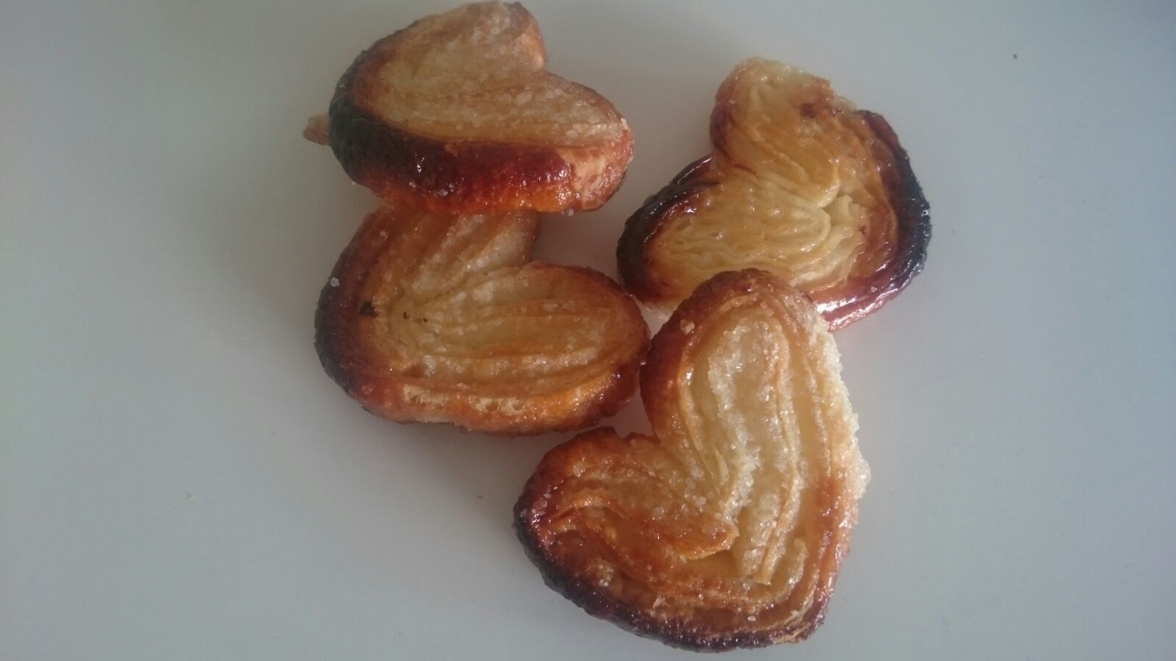

Recipe created by Irene Gomez Cedenilla

Palmeritas
It is a candy that you can have for breakfast. You can also eat it in the evening.  Preparation:  First, sprinkle sugar on greaseproof paper, put the puff pastry dough on a tray and sprinkle a lot of sugar on top of it again.  To create a perfect shape, fold the sides to the centre.  Cut the dough into squares.  Now, preheat the oven at 220º C.  Put the squares into the oven. Make sure that you always leave a gap of 1cm between two squares, because when the pastry is baked, it grows and, otherwise, the units will stick together.  time KCal People Style Type Level Cost  10 minutes 60 5 other snack easy expensive | Ingredients:  Dough of puff pastry and sugar.  Tips:  You can cover the palmeritas with chocolate. Just melt the chocolate, cover the palmeritas with it and put them into the fridge.

Weißbrot

Recipe created by Christina Palm

white bread
time | KCal | People | Style | Type | Level | Cost
ca, 105 min | 4456,9 | 5 | other | snack | medium | cheap

Batido verde

Recipe created by Sergio Heredia de Marcos

Green Smoothie
It´s a smoothie made of fruits and vegetables with a high quantity of positive properties for our organism.  Preparation:  First, we remove the seeds from the pomegranade.  Then we peel the two oranges and peal.  We put in a bowl the two cups of spinach and a cup of water.  Then we will mix those ingredients and we will get a green mixture.  Next, we put in the bowl the rest of the ingredients and mix all together.  We mix all the ingredients and we will get a mixture.  Then we serve the mixture in a glass and we can decorate it with pomegranade seeds, slices of orange or other things.  time KCal People Style Type Level Cost  15 minutes 123 4 other others easy cheap | Ingredients:  - 2 oranges  - 2 cups of spinach  - 1 pomegranade  - 1 peal  - 1 cup of water  Tips:  You can change or add other ingredients to obtain other smoothies with different healthy properties for our organism.  You can change or add other ingredients to obtain other smoothies with different healthy properties for our organism.

Rheinisches Weißbrot
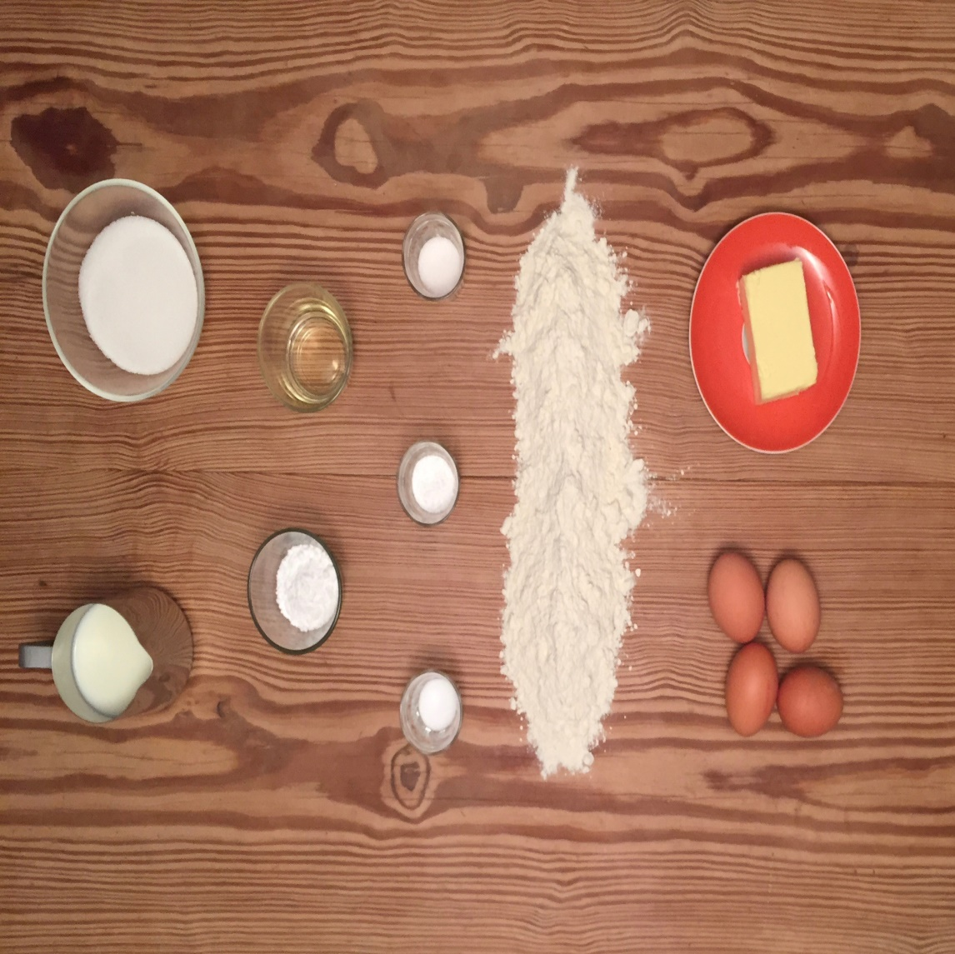 | 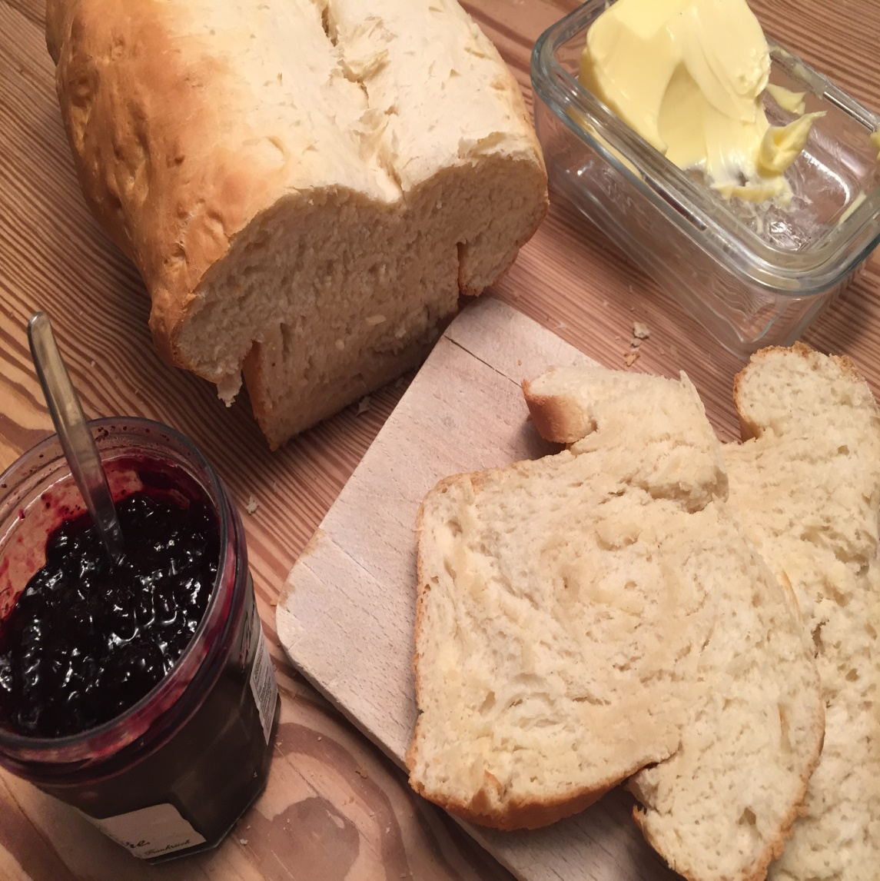

Recipe created by Christina Palm

White bread
time | KCal | People | Style | Type | Level | Cost
2 hour | 4456,9 |  | other | others | easy | cheap

Gerstensuppe
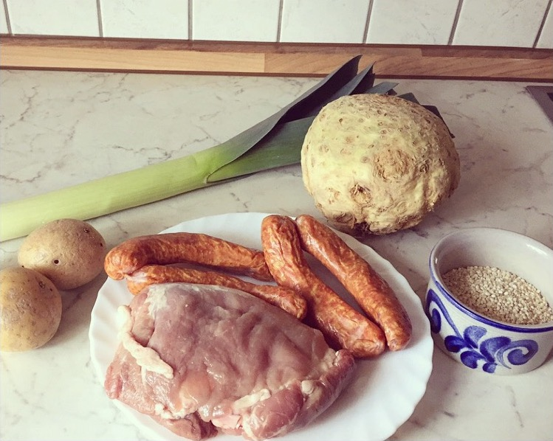 | 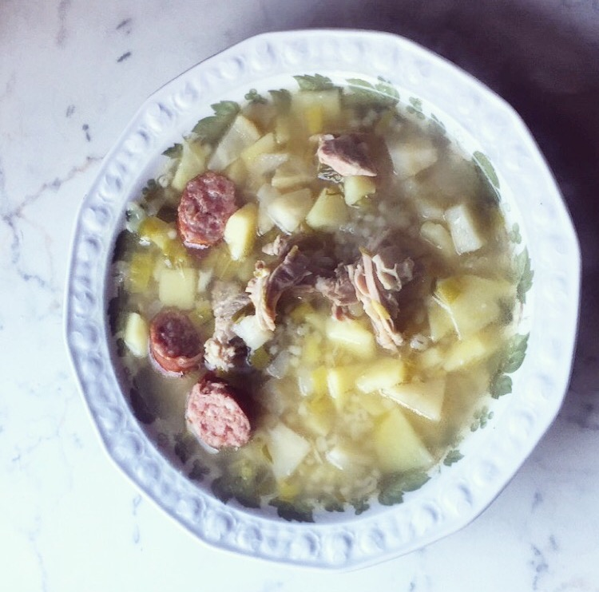

Recipe created by Charlotte Heinze

Barley soup
Preparation:  1. Put the barley in to a little pot with cold water.  2. Bring to boil briefly, let them soak on a small flame and then stir sometimes.  3. After that season the meet with salt and pepper.  4. Put the meet, leek and celery into a pot of water and boil them for 1 hour.  5. Then cut the potatoes into cubes and add them to the pot and let the ingredients boil for one more hour.  6. Add the barleys (without any liquid) for the last 10 minutes.  time KCal People Style Type Level Cost  1-2 h 165 per serving 4-5 soup main course easy cheap | Ingredients:  250g spare ribs  4 smoked sausages  1 leek  1/2 celery  potatoes  125g barley, coarse or medium  salt  pepper  nutmeg

Rheinischer Sauerbraten

Recipe created by Finn Lucka

Braised beef “Rhineland style”
Yummy! Classic! Sauerbraten is a German pot roast that can be prepared with a variety of meats—most often beef, but also from venison, lamb, mutton, pork, and traditionally, horse. Before cooking, the cut of meat is marinated for several days (recipes vary from three to ten days) in a mixture of vinegar or wine, water, herbs, spices, and seasonings.  Preparation:  1. Put the beef into a bowl filled with 250ml vinegar, 250ml water, 5 peppercorns & ½ teaspoon mustard seeds. Peel the onions and add them to the bowl after chopping them into small cubes. Keep the bowl in a cool place for 3 days. Don’t forget to turn the beef every now and then!  2. Take the beef and dry it off. Heat the grease and roast the beef gently for 15 minutes. Add the all of the broth, the red vine and 100ml of the marinade/basting sauce. Let it cook for 1 hour. Now crumble the gingerbread into very small pieces and stew it with the beef for 10 minutes. Take out the beef and keep it warm.  3. Sieve the meat stock and boil it up. Whisk the flour with the cream, add it to the meat stock and cook it for 5 minutes. Append the raisins. Season the sauce with salt and sugar. Dinner’s ready!  time KCal People Style Type Level Cost  20 minutes (+4 days margi 585 1 meat main course difficult expensive | Ingredients:  - 1 kg beef  - 250ml vinegar  - 1 bay leaf  - 5 peppercorns  - ½ teaspoon mustard seeds  - 1 onion  - 60g grease  - 250ml broth  - 2 tablespoons red vine  - 50g gingerbread  - 1 tablespoon flour  - 80ml cream  - 250ml water  - 40g raisin  - Salt & sugar  History:  Julius Caesar has been assigned a role in the inspiration for sauerbraten as he sent amphoras filled with beef marinated in wine over the Alps to the newly founded Roman colony of Cologne. According to this legend this inspired the residents of Cologne to imitate the Roman import.While quite common, these claims are largely unsubstantiated.  Tips:  Use bay leafs to beautify the meal.  Use bay leafs to beautify the meal.

GOŁĄBKI
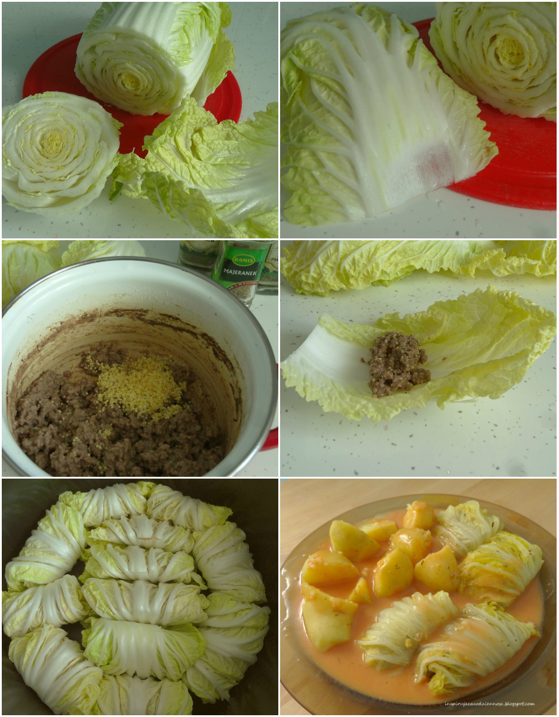 | 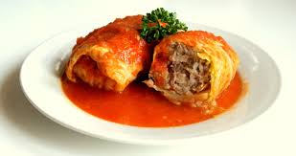

Recipe created by Weronika Chicińska

CABBAGE ROLLS
Cabbage rolls it is the meat is stuffed cabbage with rice, spices and vegetables wrapped in a pickled cabbage and cooked.  Preparation:  White cabbage boil cabbage. Heat fat and Brown it on the diced onions and garlic. To add the minced meat cooked and chilled rice, raw egg, brown out the onion and garlic and spices: salt, pepper, oregano and paprika powder. Mix everything.  Stuffing expound on the list the white cabbage and wrap.  At the bottom of the saucepan spread sauerkraut cabbage and put on her cabbage rolls. Chicken broth mixed with tomato puree and pour him cabbage rolls.  The whole thing put into the microwave oven. Bake, covered the 90-120 minutes at a temperature of 180 ° c. Before serving, cabbage rolls, you can pour the cream.  time KCal People Style Type Level Cost  1 h 300 4 meat main course medium cheap | Ingredients:  -1 cup cooked rice  - 1 head white cabbage  -2 tablespoons fat  -2 large onions  -2 cloves garlic  -45 dag ground lean pork  - 2 eggs  -salt  - pepper  -oregano  -2 teaspoons paprika powder  -45 dag sauerkraut  - ½ cup chicken broth  -½ Cup tomato puree  -2 cups of sour cream  History:  This is a traditional Polish dish, prepared from generations, my grandmother taught me how to do it. The Poles often give the cabbage rolls for foreign visitors.  Tips:  You can garnish with parsley or tomato sauce, which we receive with tomato puree, bought in the store.  You can garnish with parsley or tomato sauce, which we receive with tomato puree, bought in the store.

Bigos wegetariański
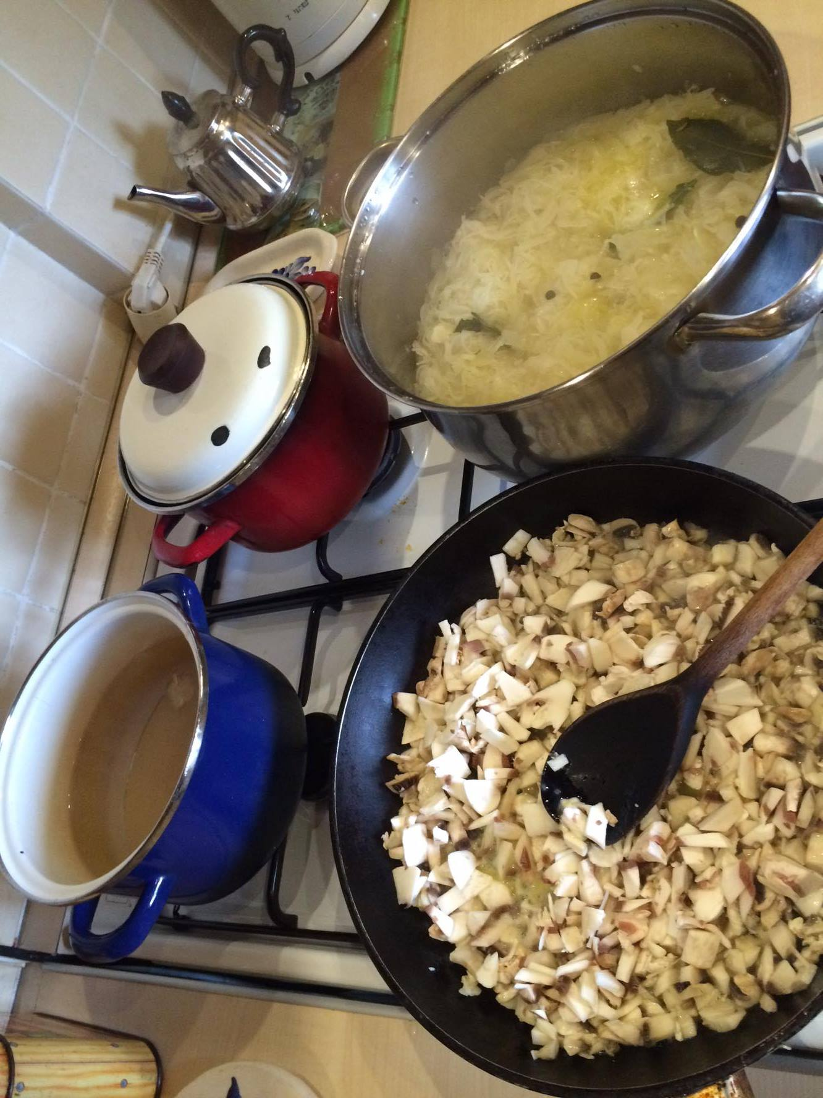 | 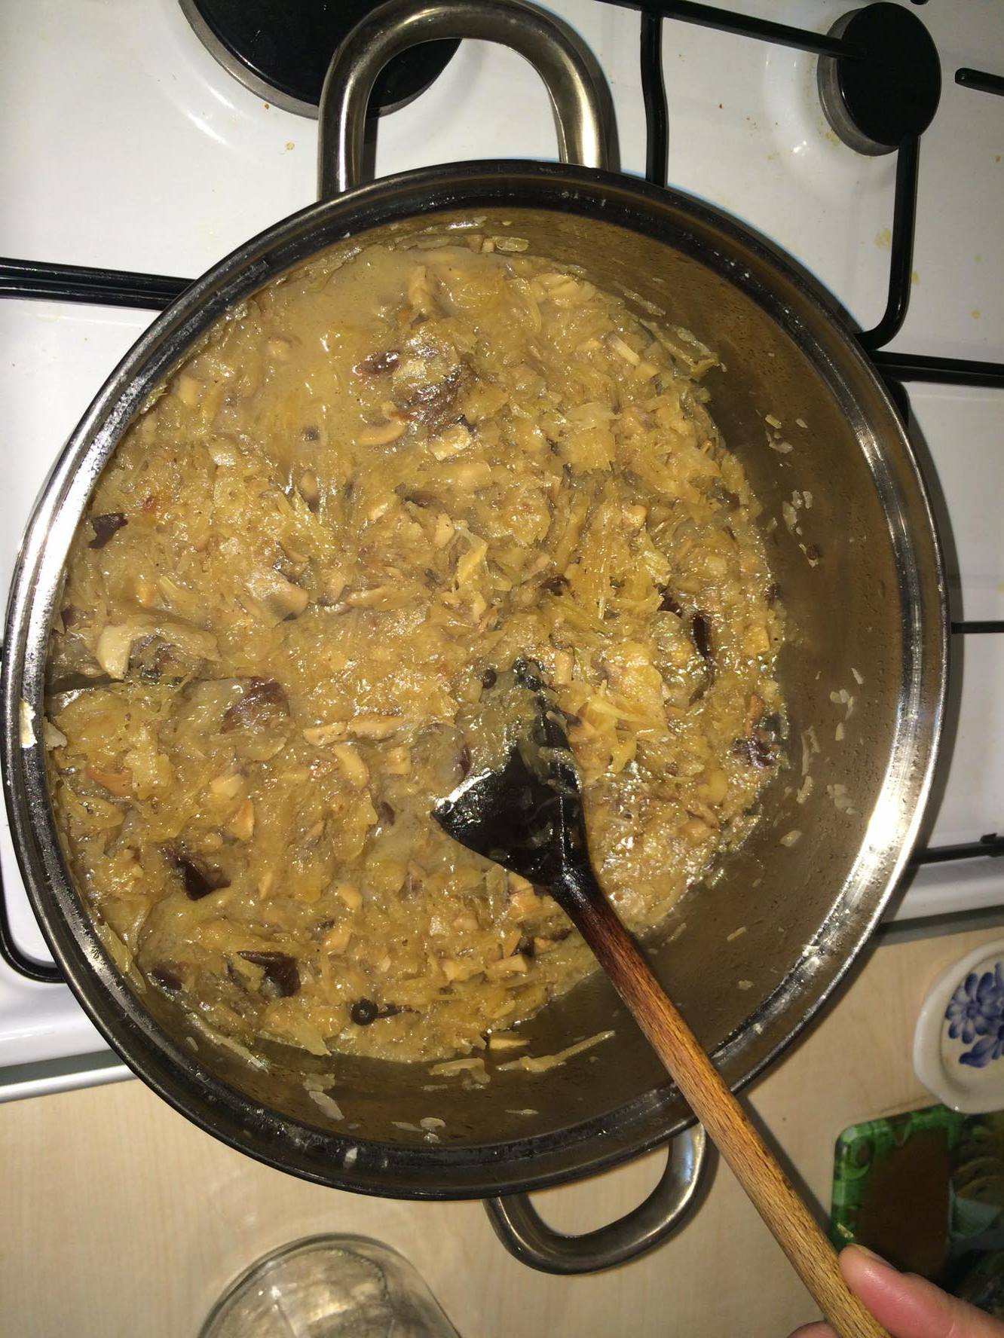

Recipe created by Asia Jerzak

Cabbage with mushrooms
Bigos is a very characteristic dish for Polish, Lithuanian and Belarusian cuisine, in this recipe presented by me in a vegetarian version.  Preparation:  First of all, rinse the sauerkraut with cold water through a sieve, put it into a pot and cover it all with water. Boil it for 2-4 minutes. Drain it. You may need to leave some water in another pot or a bowl, in case you need to sour your dish later. Then, once again, pour one liter into the pot with sauerkraut. Add allspice, the bay leaf and 5 decagrams of butter. When your dish is steaming, fry mushrooms adding the rest of the butter. (5 decagrams). Then also fry two onions.  After an hour of cooking your sauerkraut with spices, add fried mushrooms and onion. Cook for 40 minutes and add soaked in water prunes, including the water. Add salt and pepper.  ENJOY YOUR MEAL! SMACZNEGO! BUEN PROVECHO!  time KCal People Style Type Level Cost  2hours 4 vegetable main course easy cheap | Ingredients:  Ingredients:  • 1 kilogram of sauerkraut  • Half kilogram of mushrooms  • 10 decagrams of butter  • 15 prunes  • 2 onions  • Allspice  • Bay leaf  • Pepper and salt  History:  Cabbage with mushrooms (vegetarian bigos) was invented in XV century when the housewives tried to use all the leftovers from the Christmas Eve dinner.  Tips:  It tastes the best served with bread and butter or boiled potatoes.  It tastes the best served with bread and butter or boiled potatoes.

KARP W GALARECIE
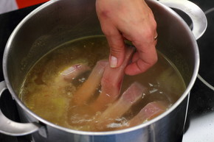 | 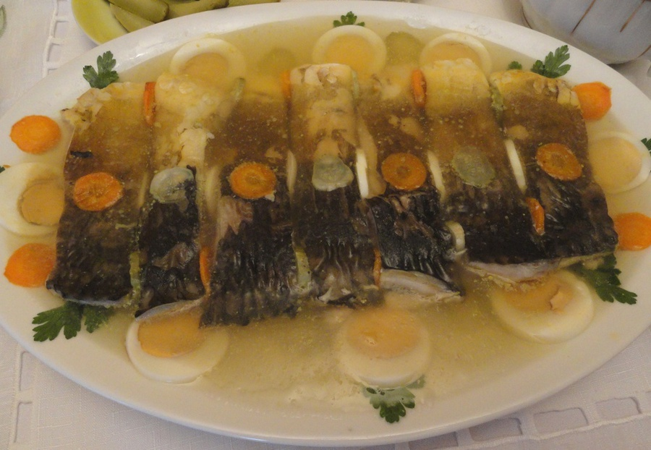

Recipe created by Weronika Chicińska

CARP IN ASPIC
Carp is one of the favorite Polish fish. He is living, inter alia, in the Baltic and Polish ponds and lakes. You can prepare it in a lot of ways, but the carp in aspic is one of the best.  Preparation:  1.Vegetables with Greens and onions into clean pot, salt, add a touch of sugar and cook the broth.  2.Add bay leaf, grains of pepper and allspice.  3.Then the broth, carefully insert a ringing fish and simmer Cook 15-20 minutes. Remove a spoon.  4.Strain broth. Carrots from broth cut, use to decorate dishes.  5.Soak gelatin in a small amount of cold water. Add to broth, add lightly beaten egg whites and vinegar. Stirring the whole thing cook to simmer until the broth has clarified in August. Strain again.  6.At the bottom of the plate pour a little broth.  7.Let cool to froze. Then put a layer of vegetables and fish. Decorate. Pour the rest of the concoction.  8.Insert into the refrigerator, and leave to set.  time KCal People Style Type Level Cost  45 min 310 4 fish main course medium medium | Ingredients:  -carp (approx 1 kg)  - a bunch of Greens  - 2 onions  -a few grains of allspice and pepper  -bay leaf  -salt  - sugar  -2 egg whites  - 2 tablespoons white vinegar  -2 teaspoons gelatine  -dill, green beans to decorate  History:  In the Polish tradition during Christmas and Christmas Eve on the table is a carp. It is one of the twelve dishes.  Tips:  You can garnish with lettuce or parsley.  You can garnish with lettuce or parsley.

Rosół
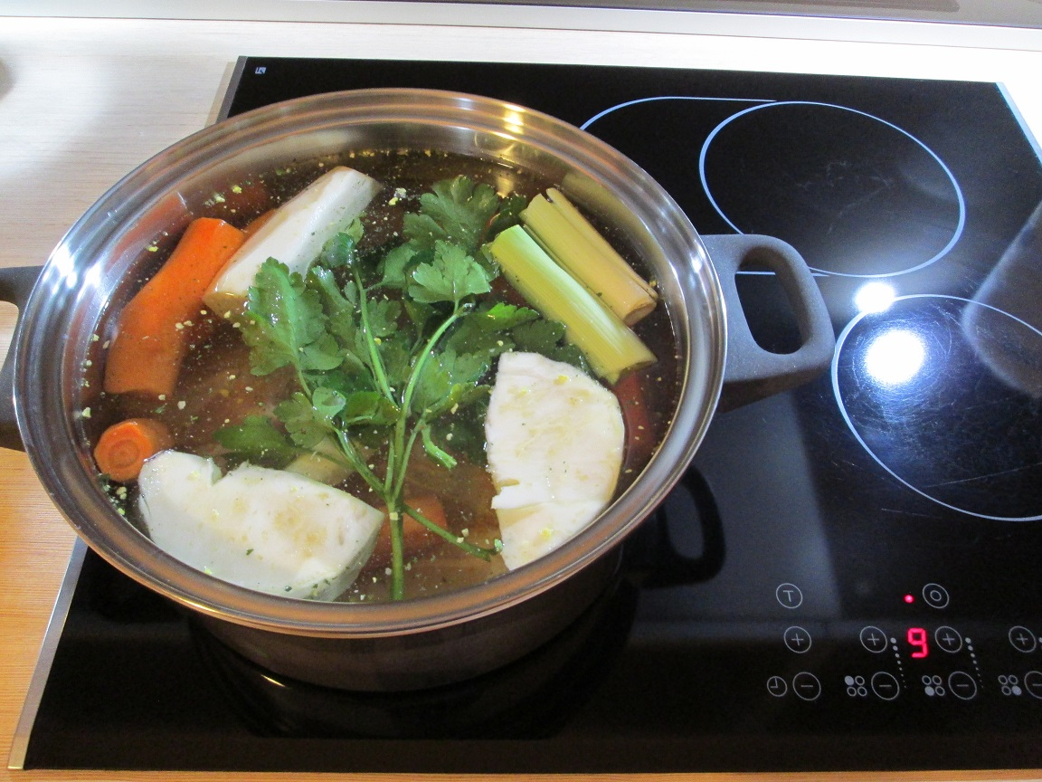 | 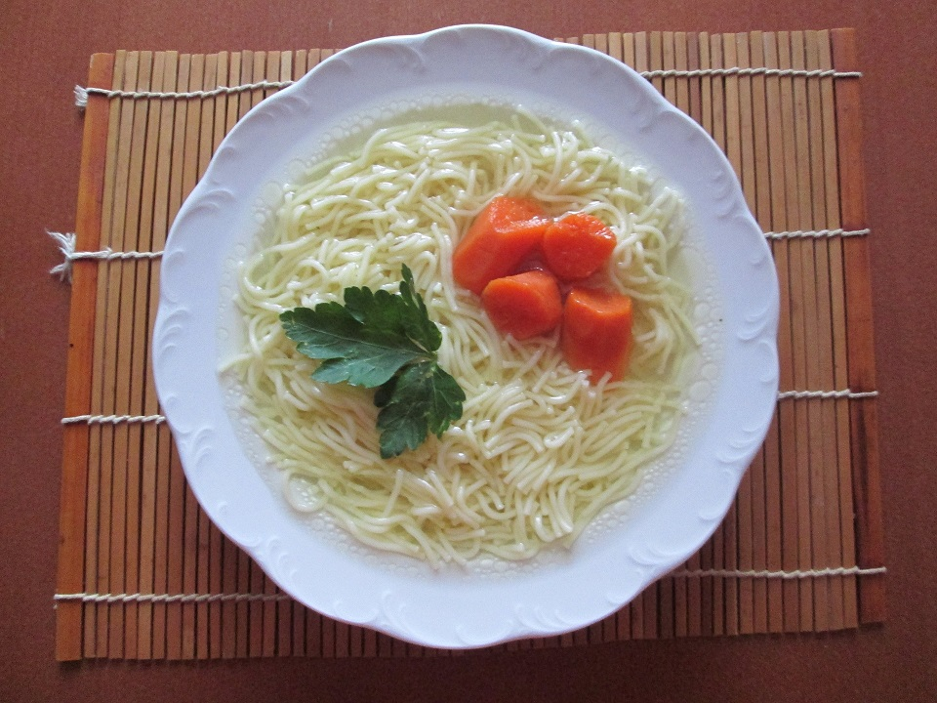

Recipe created by Kacper Wieczorek andamp; Mateusz Lub

Chicken soup
Chicken soup is very popular in Poland because it is healthy, tasty, inexpensive and easy to prepare .  Preparation:  To a large pot put chicken legs which must be previously separated from the skin, vegetables (greens), everything sprinkle any, ready mix of spices and add the parsley. The entire cover with water so that it covered all the ingredients. Cook 2-3 hours on low heat. Add seasoning liquid to taste. Serve with your favourite pasta.  time KCal People Style Type Level Cost  2 hours 56 4 soup main course easy cheap | Ingredients:  - Chicken legs  - Greens  - Parsley  - Blend of spices  - Pasta  History:  In the past, when there were no refrigerators only ways of preserving the meat was, among others, smoking, drying or salting. Meat dried and sprinkled with salt became hard, and to get a soft structure and get rid of excess salt boiling them in the water.  Tips:  Add some chili pepper to make chicken soup more spicy.  Add some chili pepper to make chicken soup more spicy.

Pulpo a la gallega
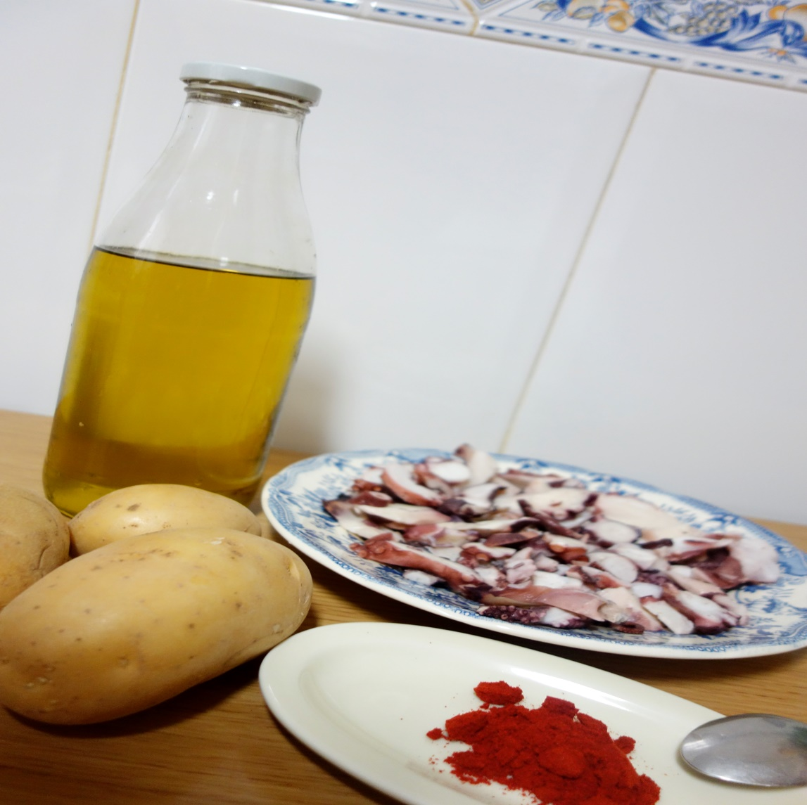 | 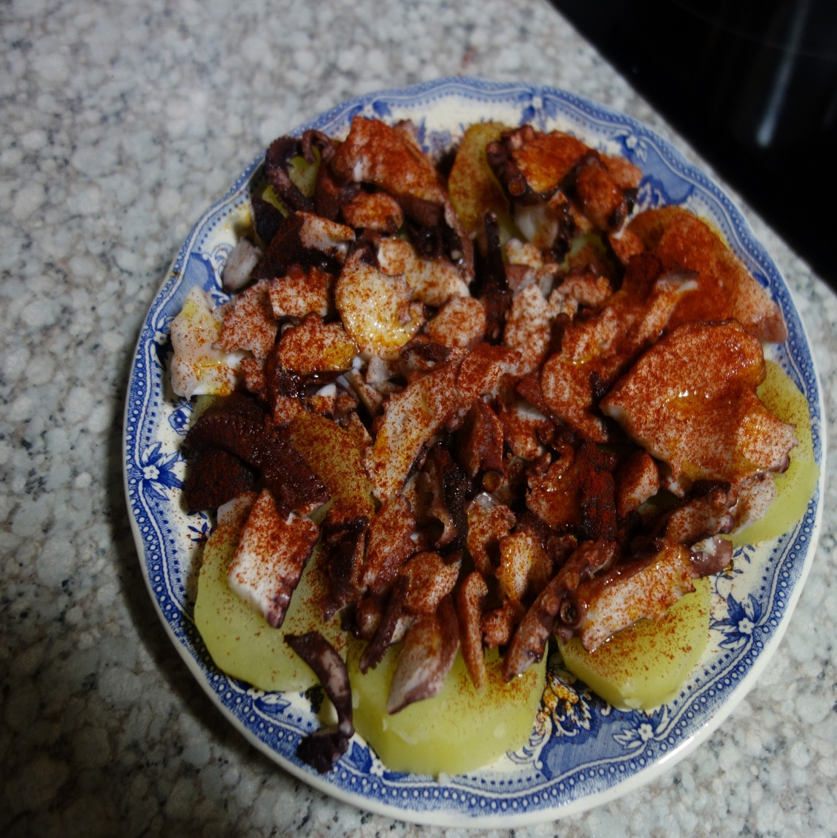

Recipe created by Diego Rodrandiacute;guez

Galician octopus
This recipe is tipical from the north of Spain (Galicia).  Preparation:  We have the octopus in slices.  We have boil the potatoes with salt.  When they are boiled, cut them in medium-sized slices and put it on a plate.  Now we distribute the octopus slices on the top of the potatoes and add a little of oli, salt and paprika.  time KCal People Style Type Level Cost  20 minutes 335 2 other main course easy cheap | Ingredients:  Octopus in slices, potatoes, oil, salt and paprika.  Tips:  When you have the octopus on the top of the potatoes, add paprika with a colander.

Grünkohl
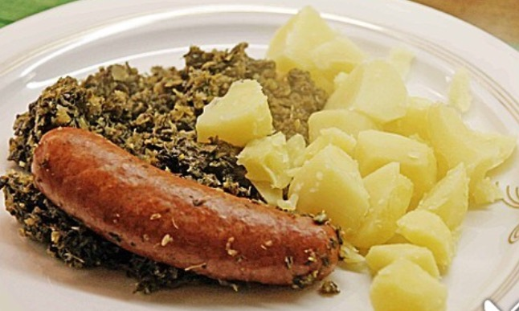

Recipe created by Elena

Green cabbage
Green cabbage is a traditional German dish.  Preparation:  1. Cube the onion and sweat it in butter oil until it is translucent, afterwards add salt and pepper to the onion.  2. Add green cabbage, stir well, raise the temperature and mold on the broth -> cook at a middle temperature with a closed cover plate for 20 minutes.  3. Meanwhile peel and cube the potatoes. After cooking time, add the potatoes, stir well, put on the cover plate and simmer for 20 minutes.  4. Then add the mettwursts , cook them for 10 minutes. Take out the mettwursts, slice them and put them back into the pot again.  5. Flavour according to your own taste.  time KCal People Style Type Level Cost  50 minutes 131kcal 2-4 vegetable main course easy cheap | Ingredients:  • 1kg green cabbage  • 1 onion  • 1l strong broth  • 700g of potatoes  • 4 mettwursts  • Salt, pepper, butter oil

Himmel und Äd

Recipe created by Christina Palm

Heaven and Earth
Preparation:  • First peel the potatoes. Then  with butter and salt and refine it with a pinch of nutmeg mix it all.  • Next peel the apples, remove the pills and split it in four parts. Season it with sugar and lemon juice and cook it soft with a little bit of water. Mash it up and mix it with the mashed potatoes. Cut the shallots in stripes and roast them goldy.  • Then peel the black pudding, cut it thick as fingers and turn it in the flour.  • Bake it with the lard crispy.  • At last divide the puree on the plates, put the black pudding on it and divide the  roasted shallots on it as well and enjoy your meal! Guten Appetit!  time KCal People Style Type Level Cost  meat main course medium medium | Ingredients:  1 kg potatoes (mealy) 1/4 l milk  6 appels (boskopp) 500 g shallots  lard  some flour  50 g butter  salt and nutmeg  3 ts sugar  1 ring black pudding 1 lemon  History:  Good to know: This meal has been known since the 18th century. The right name is „Himmel und Erde“ and it means „heaven" for the apples on the trees and „earth“ for the potatoes (in german „earth-apples“) in the ground.

Lauchkuchen

Recipe created by Jana Kröse

Leek cake
Preparation:  1. First, you have to put flour, with one egg, butter, some salt and one tablespoon of cold water together in one bowl. Then you knead it to bound mass.  2. After that you have to grease the spring-clip tin, then put the dough in and place it in the refrigerator for ca. 30 minutes. In this time you cut the leek in small rings. And preheat the oven.  3. Now the diced ham gets seared with some oil in a pan. Simultaneously the rest of the creme and the other eggs get mixed in a bowl and seasoned with salt, pepper, nutmeg and other stuff you like.  4. In the next step you put the leekrings in the hot pan and start sweating it for up to 10 minutes, otherwise the leek will be very firm later.  5. At last you put the crème-egg-mix in the spring-clip tin and cover it with grated cheese. Afterwards you put it in the oven by 200C for 30 minutes.  time KCal People Style Type Level Cost  45-50 min. 5-6 other main course easy cheap | Ingredients:  Ingredients:  • 1 kg leek  • 400 g diced ham  • 200 g creme  • 200 g grated cheese  • salt, pepper, nutmeg, etc.  • oil (to saut)  • fat for the baking tin  • spring-clip tin  28 cm  For the dough:  250 g four  • 125 g soft butter  • 5 eggs  • 1 table spoon cold water  History:  Leek cake is a recipe that do not need much ingerdiens and espacially no special ones. That the reason why in previous times also normal people liked this recipe very much, especially in the Rheinland leek is grown very much so it is possible for everyone to puy it. Today not many people here know the leek cake and start to forget it.

Migas

Recipe created by Ángela García, Cati Penes y Cl

Migas
Migas is a typical Spanish dish that was usually eaten by ancient herdsmen when they took the lifestock to the mountains for feeding. The dish became popular because it made most of the leftovers from other dishes.  Preparation:  The night before...  Put de garlic bulb, oregano and salt in the mortar and pound it. Prepare the mixture with sweet paprika, garlic bulb, oregano and 1 liter of water.  Wet the bread crumbs slowly with waterdrops.  Cut the chorizo and bacon in cubes, in a pan with four tbs of olive oil.  Fry first the choriza and the bacon and then, remove with a skimmer .  After that, put it in a plate and leave apart.  Add the breadcrumbs to the remaining oil of the fried chorizo and bacon adding paprika until the breadcrumbs are orange.  When the migas are dry and orange they are ready.  Fry an egg and put the breadcrumbs in a plate along with the chorizo and bacon.  time KCal People Style Type Level Cost  30 - 45 minutes 500 6 meat main course medium medium | Ingredients:  Crumbs of 2 loaf of bread  1 garlic bulb  30 grams of Spanish sweet pimentón  200 grams of bacon  100 grams of chorizo (more or less)  Salt  1 cup of olive oil  History:  Migas is a typical dish of the Spanish culture. It has its origin in the Muslim culture. With the Arab invasion the people adopted new ways to cook bread. It’s thought that the pioneering dish of migas comes from the Andalusian cuisine. During this period it was considered as a dish to serve to important guests, although they were also prepared by different social classes and in various forms. Over the years, people were introducing different ingredients like pepper, sausage …  In the XVI century, migas were cooked by shepherds on Sunday, using the hard bread they left over and the limited ingredients they had. Migas were forgotten until the end of the XIX century, when the writer Emilia Pardo Bazán included the recipe of migas in her book “Old and modern Spanish cuisine”.  Given the origin of migas, you can see that in the Peninsula there are different ways to prepare migas, it depends on the Autonomous Community.  Migas manchegas are from Castilla La Mancha. They were prepared with hard bread, garlic, oil, sausage, bacon, pepper, water and salt.  Migas manchegas are very important for Castilla La Mancha because it’s a traditional dish of Spain. This meal fed the shepherds of Castilla La Mancha over many years. They were also cooked for breakfast for Spanish soldiers in the military academies.  Tips:  You can add a fried egg to migas

Muscheln rheinischer Art
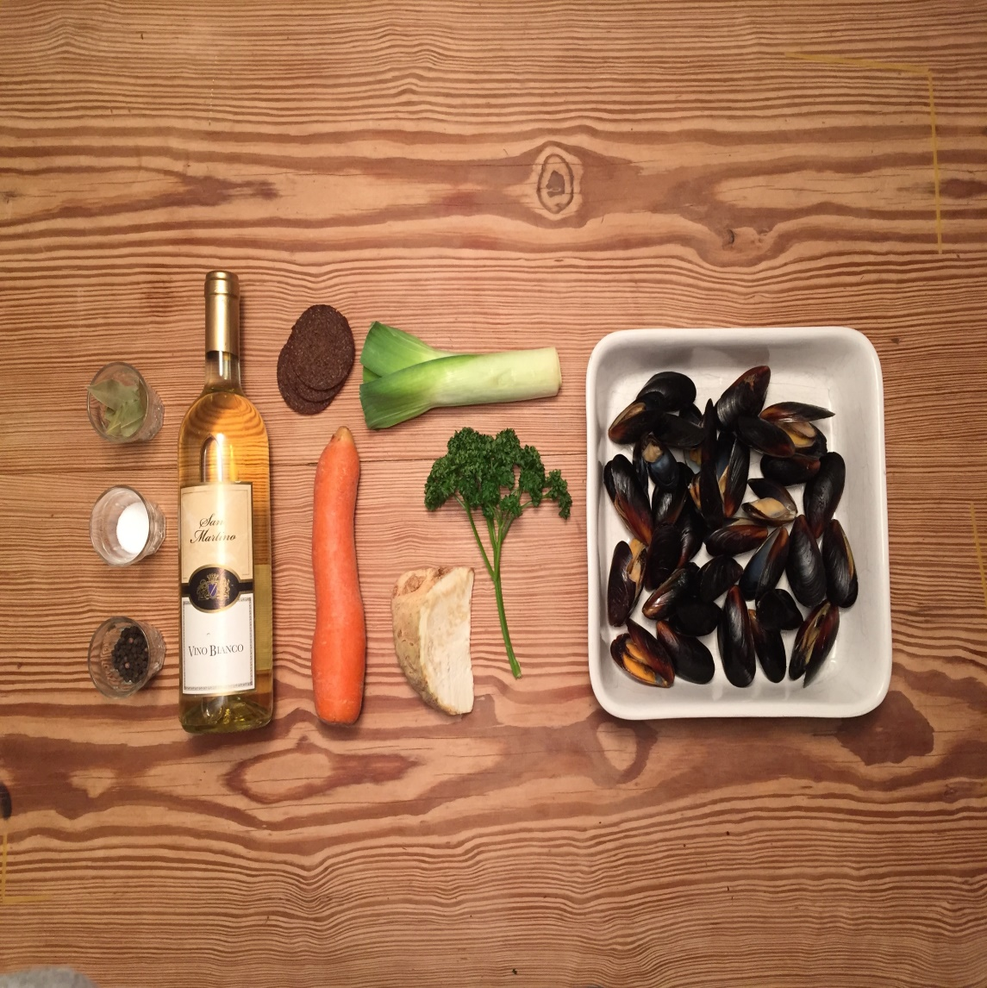 | 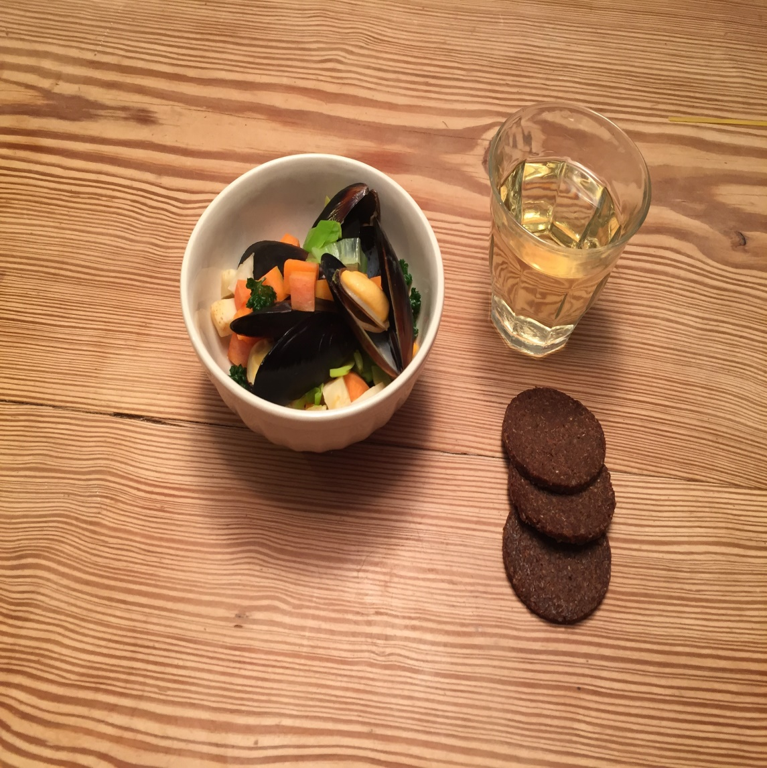

Recipe created by Linda Bahun

Mussels
Mussels in vegetable soup with black bread  Preparation:  First clean the mussels and cook them 7 minutes (hottest/big flame) in the soup of a little bit cold water, spices and clean and hacked soup vegetables (onions, leek, celery). Serve the mussels on a warm plate and pour some soup over them.  time KCal People Style Type Level Cost  30 Minutes 2040,2 4 other main course easy medium | Ingredients:  3kg mussels  250g onions  1 strand leek  1 celery tuber  salt  pepper  bay leaf  1/4 l water  Tips:  Savor it with traditional black bread and butter.  Savor it with traditional black bread and butter.

Schabowy z pieczarkami
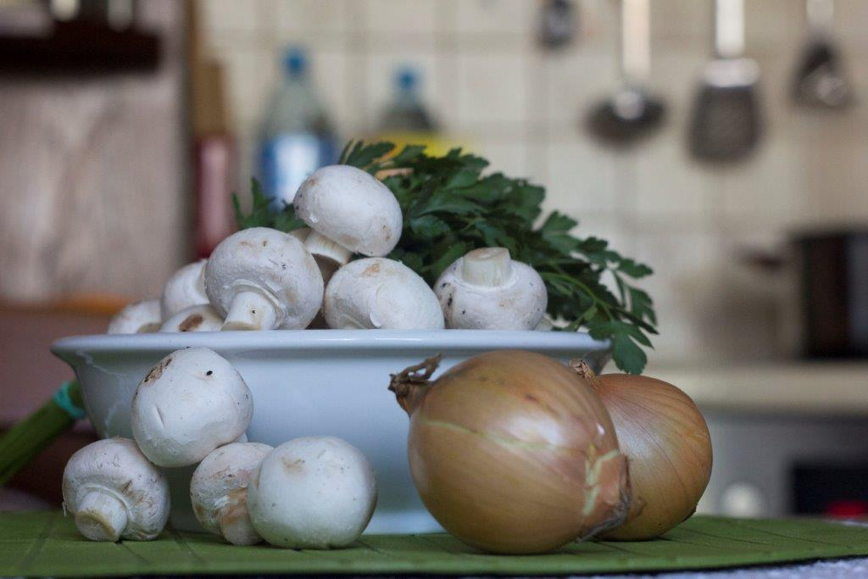 | 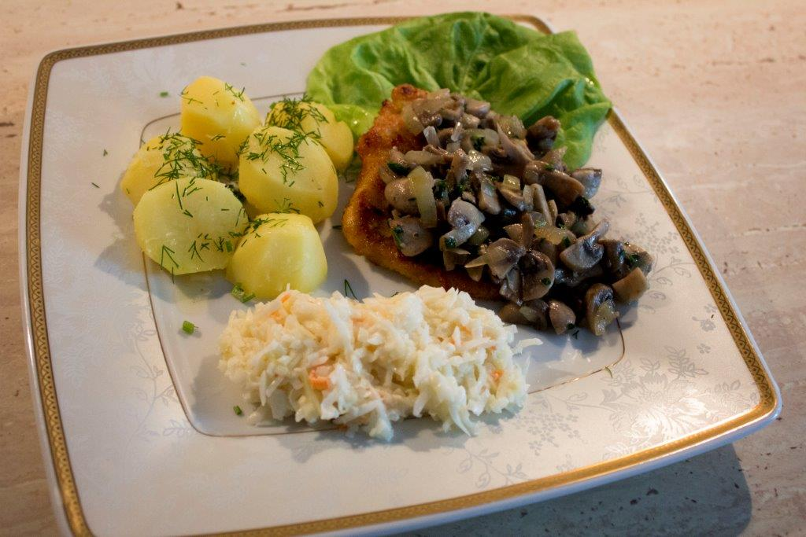

Recipe created by Konrad Fiała

Pork chop with mushrooms
Chop is probably the most popular dish in Poland. It is a symbol of Polish cuisine. This recipe is an interesting version of this delicious dish.  Preparation:  Peel onions and cut. Toss in the pan on a little hot oil. Season with salt to taste. Fry on low heat, until the onion has softened. Put the plate.  Washed sliced ​​mushrooms in the cat throw the pan slightly hot oil (small amount of oil, because mushrooms wilderness juice). Season with salt and pepper. Simmer, covered, until tender. Stir occasionally.  To add mushrooms fried onions and add the chopped parsley. Stir and ready.  Pork Loin wash, obsuszyć and cut into 4-5 chops. Meat beat, salt and pepper.  Roztrzebać egg with a fork on a plate and a second plate sprinkle breadcrumbs.  Chops soak in egg and coat in breadcrumbs. Fry.  Serve with boiled potatoes sprinkled with chopped dill and salad.  Bon Appetit  time KCal People Style Type Level Cost  30 minutes 411 4-5 meat main course medium cheap | Ingredients:  1 kg of mushrooms  2 large onions  parsley  0,5 kg of boneless pork loin  1 egg  bread crumbs  pepper and salt  frying oil  History:  My great-grandmother created this recipe.  Tips:  Use a lot of salt and pepper.  Use a lot of salt and pepper.

Rheinische Kartoffelklöße

Recipe created by Anton Kamps

Rheinische Kartoffelklöße
Preparation:  Firstly  wash the potatos  brush the potatos under running water clean  simmer the potatos in water for around 20 Minutes  after simmering the potatos let them cool down and peel them  during peeling make some milk boiling  Secondly  Slice the bun in small slices  pour over the boiling milk  separate the yellow and the white part of the eggs  squeeze the potatos threw the ricer  Thirdly  Foam up the first half of the butter  Mix in first the yellow part of the egg and second the spices  Fourthly  add the soaked bun and the potatos and mix it  whip the white part of the egg and add it to the the patato mixture  wash the parsley dry it up and hack it up  Fifthly  Kneat the dough and the parsley together and taste it with salt, pepper and fresh nutmeg  Heat up the second part of the butter in a big pan  Devide the mixture in small portions and brown the  Sixtly  Take the finished dumplings out drain them and serve them  time KCal People Style Type Level Cost  45 443 4 vegetable main course medium medium | Ingredients:  500 g potato  125 ml milk  1 old bun  3 eggs  125 g butter  salt, pepper  nutmeg  1/2 bunch of parsley  Tips:  An idea for serving is:  add some meat

Rheinische Pepse
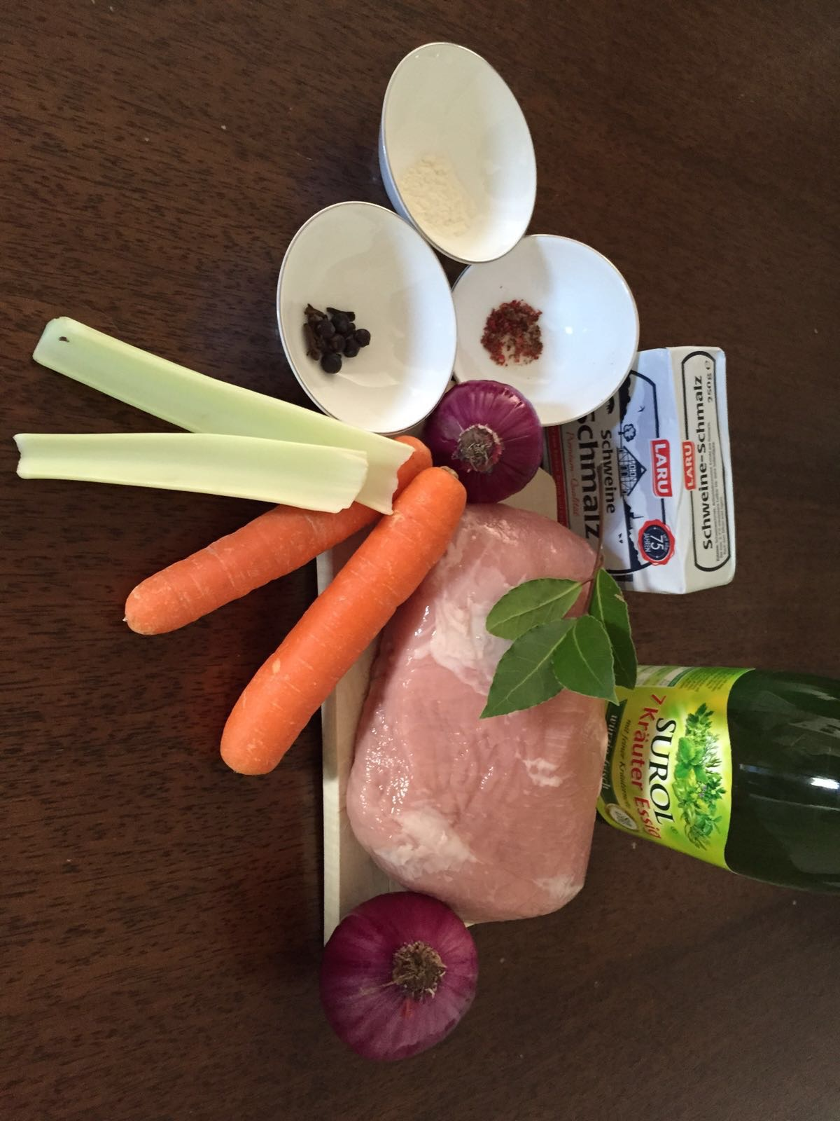 | 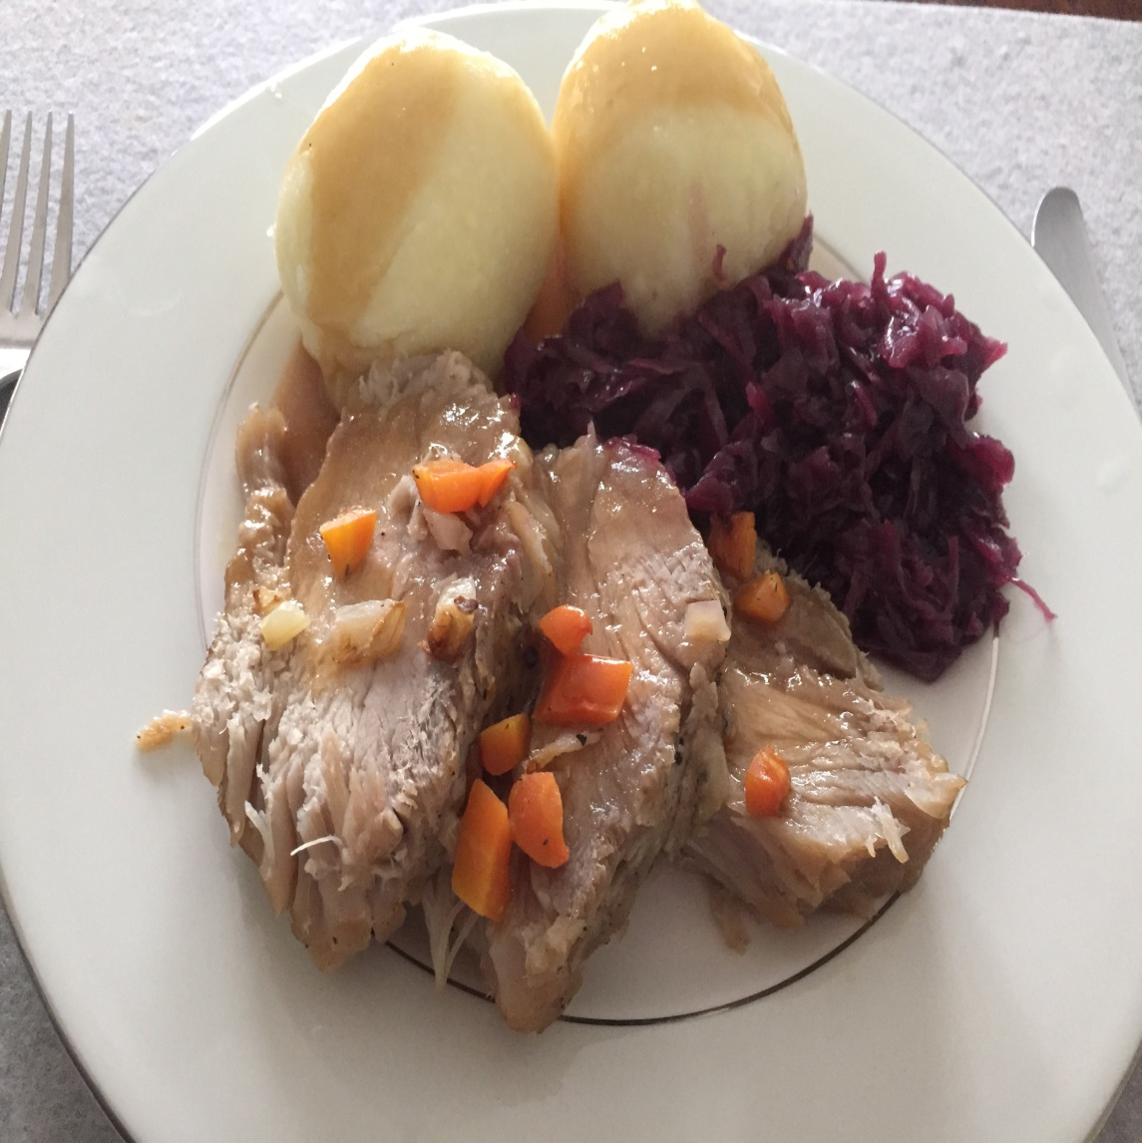

Recipe created by Till Engel

Rheinische Pepse
A Sauerbraten is pretreated braised roast by several days marinating it in a pickle of vinegar and other ingredients.The braised beef is in its different regional variants a known traditional dish of German cuisine.  Preparation:  1. Put the beef into a bowl filled with 250ml vinegar, 250ml water, 5 peppercorns & ½ teaspoon mustard seeds. Peel the onions and add them to the bowl after chopping them into small cubes. Keep the bowl in a cool place for 3 days. Don’t forget to turn the beef every now and then!  2. Take the beef and dry it off. Heat the grease and roast the beef gently for 15 minutes. Add the broth, the red vine and 100ml of the marinade/basting sauce. Let it cook for 1 hour. Now crumble the gingerbread into very small pieces and stew it with the beef for 10 minutes. Take out the beef and keep it warm.  3. Sift the meat stock and boil it up. Whisk the flour with the cream, add it to the meat stock and cook it for 5 minutes. Add the raisins. Season the sauce with salt and sugar.  time KCal People Style Type Level Cost  25 Minutes 460 4 meat main course medium medium | Ingredients:  - 1 kg beef  - 250ml vinegar  - 1 bay leaf  - 5 peppercorns  - ½ teaspoon mustard seeds  - 1 onion  - 60g grease  - 250ml broth  - 2 tablespoons red vine  - 50g gingerbread  - 1 tablespoon flour  - 80ml cream  - 250ml water  - 40g raisin  - Salt & sugar  Tips:  Add some balsamic vinegar to the marinade for a refined taste with a sweet note.  Cut the meat into slices.  Add some balsamic vinegar to the marinade for a refined taste with a sweet note.  Cut the meat into slices.

Rumpsteak mit Champignongkruste
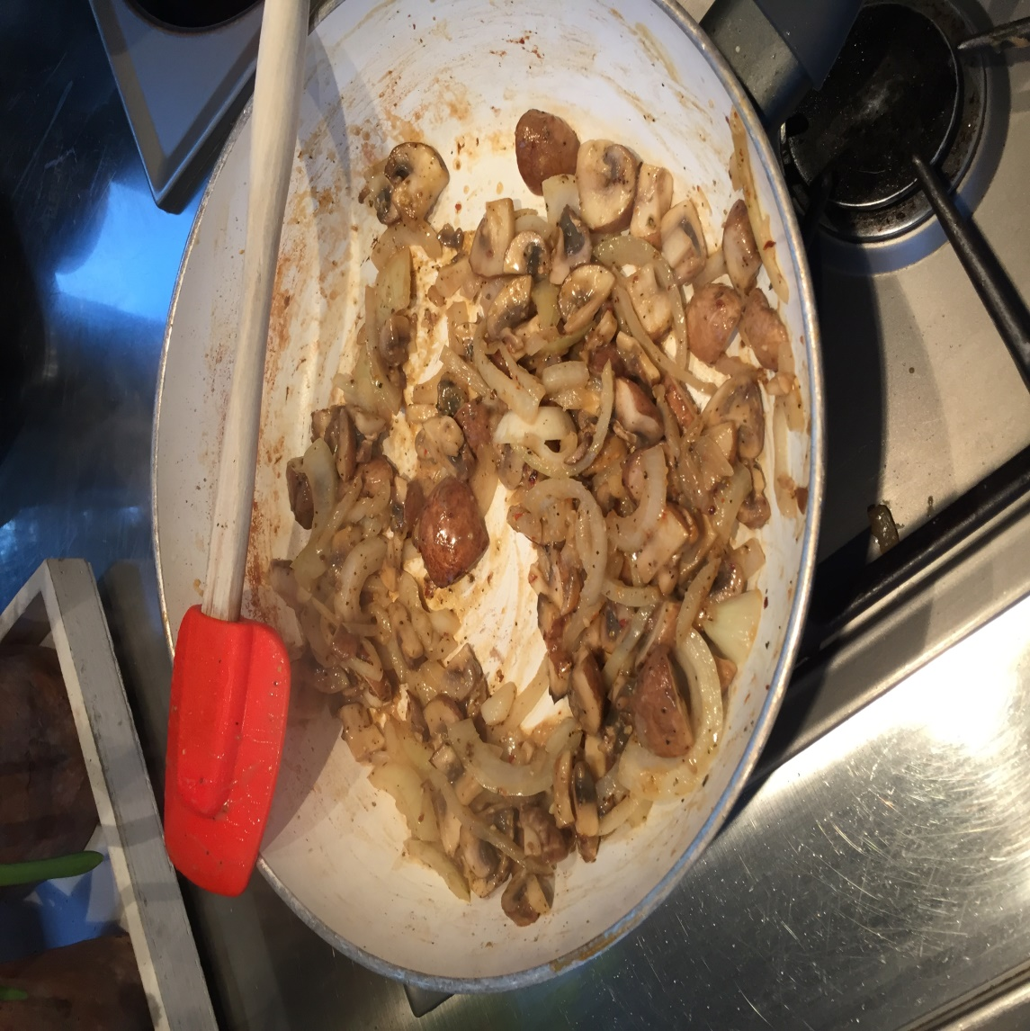 | 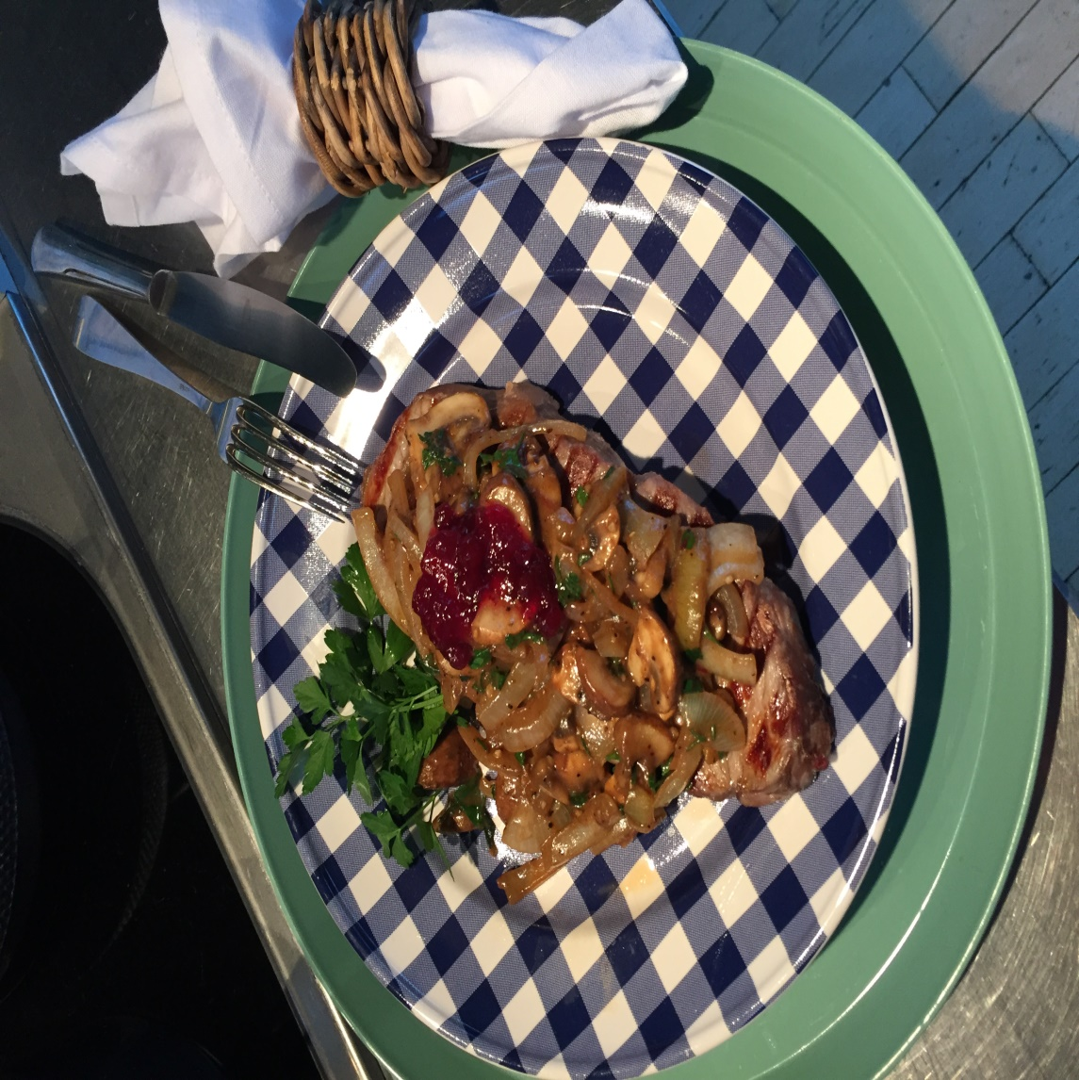

Recipe created by Gernot Welters

Rumpsteak with mushroom crust
A delicious Steak is beloved by everyone.  Preparation:  1. Brush the mushrooms, rub off and cut into cubes. The garlic and onion have to be peeled and then hack up with the capers. Everything getting mixed up with egg, the coarse mustard and breadcrumbs, and spiced by pepper.  2. Prepare the Rumpsteak with salt and pepper. In hot oil saute it on both sides. Then put on the steak the mushroom Sauce.  3. Now place the Rumpsteak in the preheated oven at 180 degree on the second slide-bar from underneath for about 12 to 15 minutes.  time KCal People Style Type Level Cost  30 minutes 1200 4 meat main course easy medium | Ingredients:  For 4 Portions:  150 g Mushrooms  1 Clove of garlic  1 Onion  1 ts Capers  1 Egg  1 ts coarse mustard  2 ts breadcrumbs  Pepper  4 Rumpsteak (à 180g)  Salt  2 ts Oil  Tips:  fried potatoes are match really good with it.  fried potatoes are match really good with it.

Tortilla Española
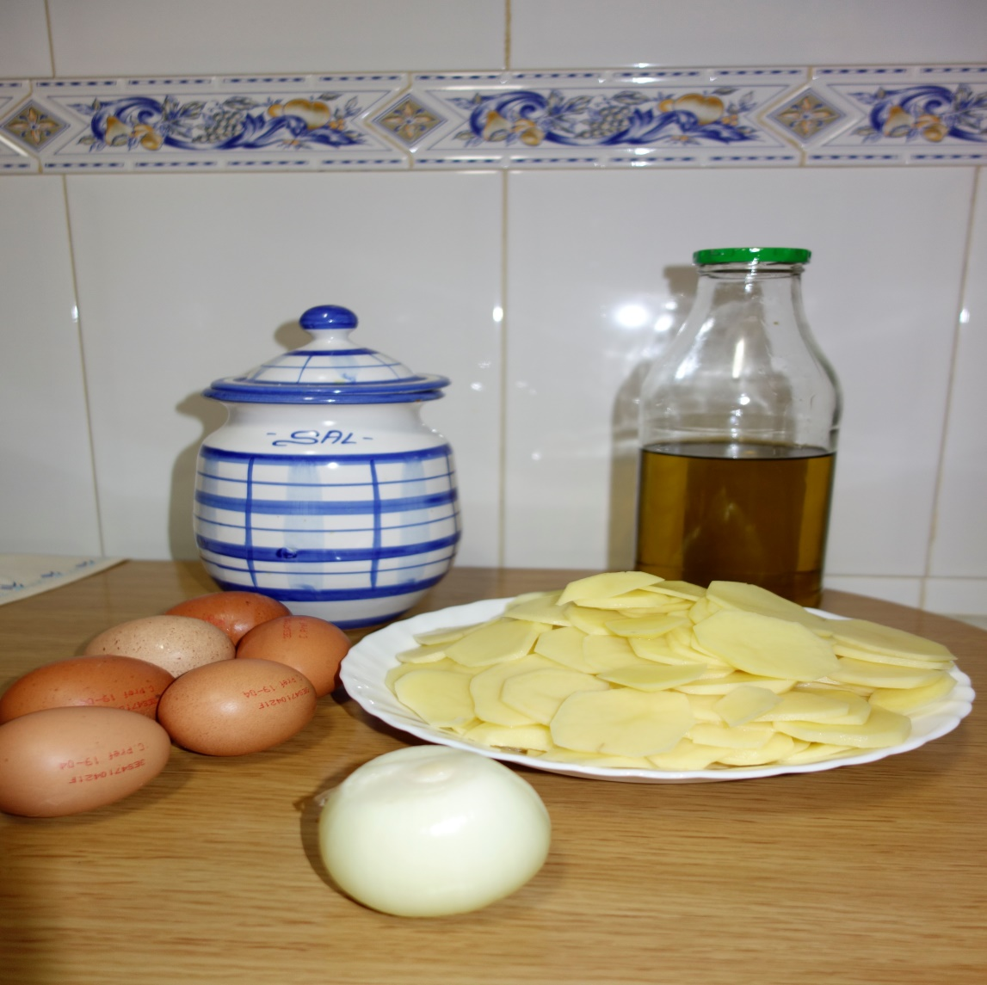 | 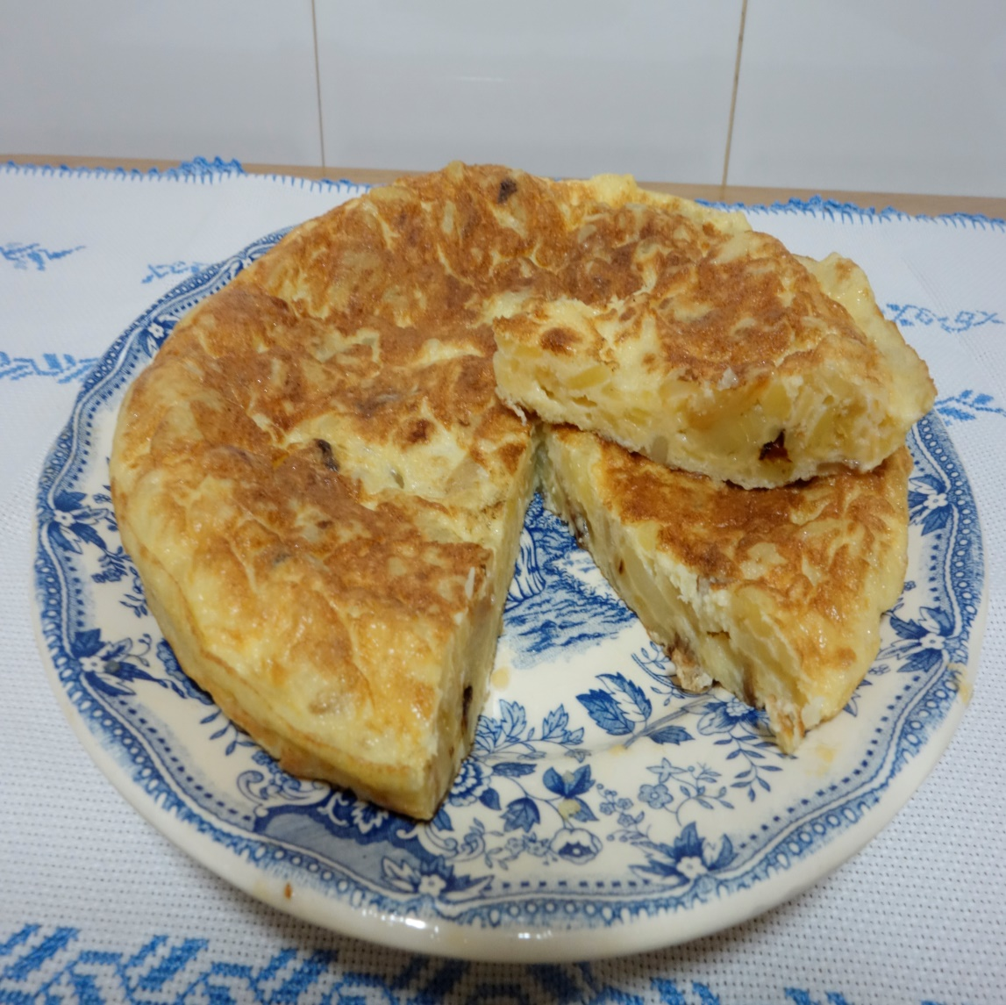

Recipe created by Ana and Diego Rodríguez Sánche

Spanish omelette
The Spanish omelette is an omelette with potatoes, but we can add ingredients like onions or sausages. It is a common recipe in Spain which is often served in a bar or a restaurant in Spain. It can be served hot or cold. Great chefs like Ferran Adrià have paid special attention to this common recipe.  Preparation:  1.Scrape the potatoes. Cut them into thick slices. Chop the onion.  2.Heat the oil in a large frying pan, add the potatoes and onion and stew gently, partially covered, for 30 minutes, stir occasionally until the potatoes are softened.  Strain the potatoes and onions through a colander into a large bowl.  3.Beat the eggs separately, and then stir into the potatoes with the salt.  Heat a little of the strained oil in a smaller pan.  Tip everything into the pan and cook on a moderate heat, using a spatula to shape the omelette into a cushion  4.When almost set, invert on a plate and slide back into the pan and cook a few more minutes.  Serve on a plate and enjoy your recipe.  time KCal People Style Type Level Cost  40 minutes 750 4 vegetable main course medium cheap | Ingredients:  500g potatoes  1 onion, preferably white  150 ml olive oil  6 eggs  History:  There are a lot of theories but the tradition of the Spanish omelette began during the Carlistas wars when an anonymous poor homemaker from Navarra who only had eggs, potatoes and onions did a mix with these ingredients that became famous.  Tips:  This omelette can be eaten hot or cold, in a sandwich or as a main course.

Möhreneintopf
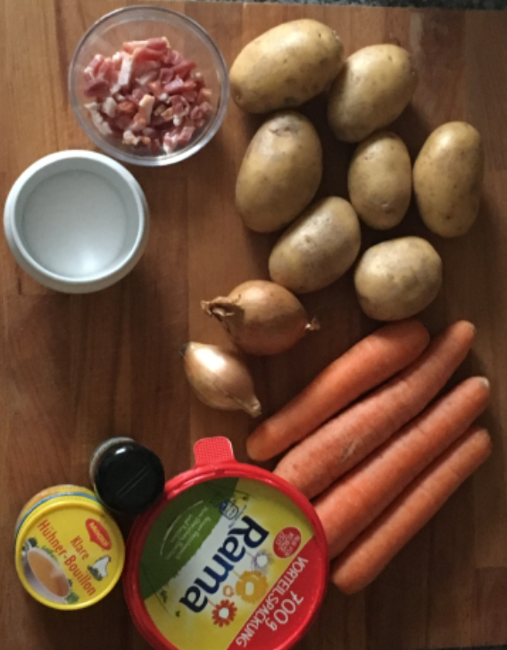 | 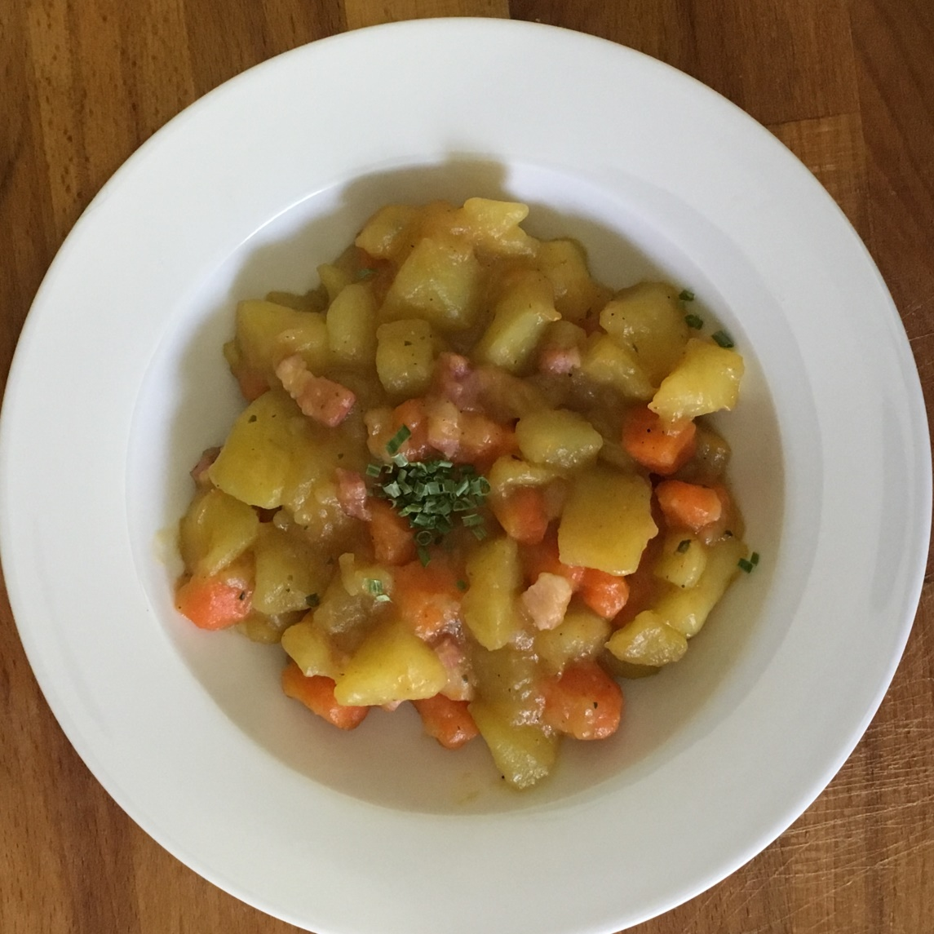

Recipe created by Lavanya

Stew of carrots
Stew of carrots is a typical German dish which will be cooked especially on cold days. The main ingredients of stew of carrots are carrots and potatoes.  Preparation:  1. clean and cube the carrots and the potatoes  2. cube the onions and roast them gently in the butter without coloring  3. add the other ingredients and the stock and cook them for 30 minutes  4. cube the bacon, add them to the stock  5. season with sugar, pepper and salt  time KCal People Style Type Level Cost  30 min 153 4 vegetable main course easy cheap | Ingredients:  1 tablespoon of butter  500 g of carrots  500 g of potatoes  1 slice of marbled bacon (50 g)  2 onions  stock at will (vegetable stock or chicken stock)  sugar, pepper, salt  Tips:  Mettwurst:  1. slice the mettwurst and roast them gently.  2. add the mettwurst to the stock.

Żurek
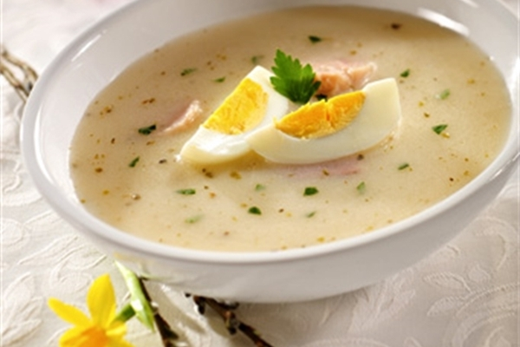

Recipe created by Zuza Wilczyńska

White soup
White soup is a sour soup, this is one of the most popular polish soup. It has got typical sour taste.  Preparation:  Rye sourdough:  1) Pour wholemeal rye flour to the jar and add 1 cup od water. Stir the mixture to form a uniform slurry. Add spices - 2 cloves of slighty crushed garlic, 2 bay leaves, 2-3 allspice berries and the peel of one slice of wholemeal bread.  2) Cover the jar with a piece of gauze or linen cloth, not close it with the lid. Set outside fot about 3-5 days in a warm place and give it a stir just once a day.  Fet it mature and sourdough will gain a distinct sour smell and taste.  Żurek soup:  1) Wash and peel onions and vegetables. Put them into a large pot and cover with water. Add garlic (2 peeled cloves), 5 allspice berries, 2 bay leaves. Boil gently for about one hour, then take out the vegetables and save the broth.  2) In the meantime, wash, peel and dice potatoes and boil them separately.  3) Add 1 cup of rye sourdough to your vegetable broth. Stirr both ingredients and boil for about 5 minutes.  4) Cut Polish raw sausage into slices, and add it to the soup with 2-3 teaspoons of marjoram and cut moked bacon.  5) Cook the soup until it gets and intense aroma of meat and herbs. Add salt and pepper to taste, then turn the heat off. Add 3-5 tablespoons of sour cream and previously boiled potatoes. Stir the soup, but do not boil it any longer.  6) Serve while still hot, with cut hard boiled eggs.  7) Enjoy your meal! :--)  time KCal People Style Type Level Cost  1 h 108 4 soup main course easy cheap | Ingredients:  Rye sourdough:  half of cup of wholemeal rye flour  peel of one slice of wholemeal bread  1 cup of room-temperature, but previously boiled water  2 cloves of slighty crushed garlic  2 bay leaves  2-3 allspice berries  Żurek soup:  vegetables: 1 carrot, half of parsley, quarter of a leek, piece of a raw cery root  2 medium sized onions  2 garlic cloves  5 allspice berries  2 bay leaves  3 medium sized potatoes  1 cup of rye sourdough  Polish raw sausage (white sausage)  smoked bacon  2-3 teaspoons of marjoram  salt  pepper  4-5 tablespoons of sour cream (18%)  hard boiled eggs  History:  White soup was a dish eaten practically every day for the duration of Lent. It was a skinny soup, which does not contain even a gram of meat, and the preparation was enough rye flour or a piece of wholemeal bread Today, we return to tradition, rediscovering its culinary benefits.  Tips:  Best served with egg.  Best served with egg.

Szarlotka
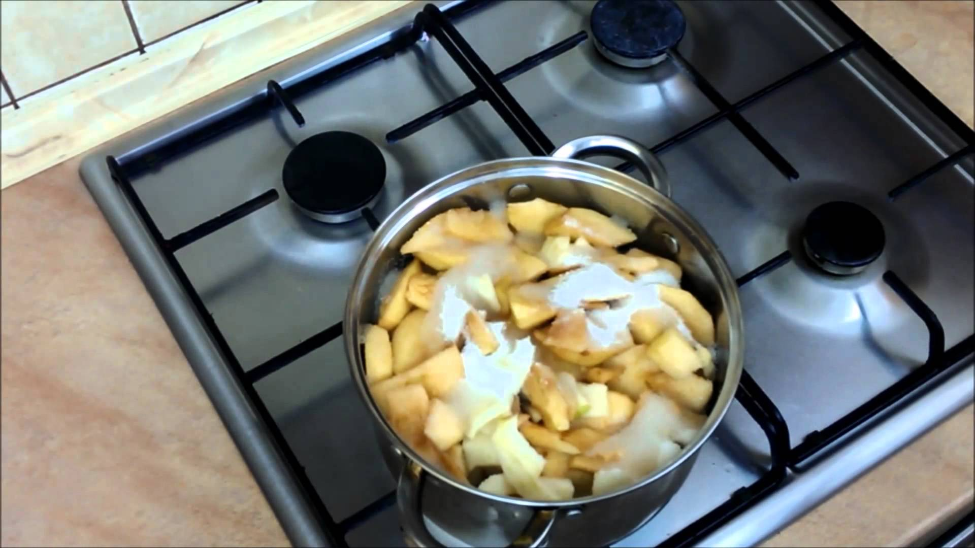 | 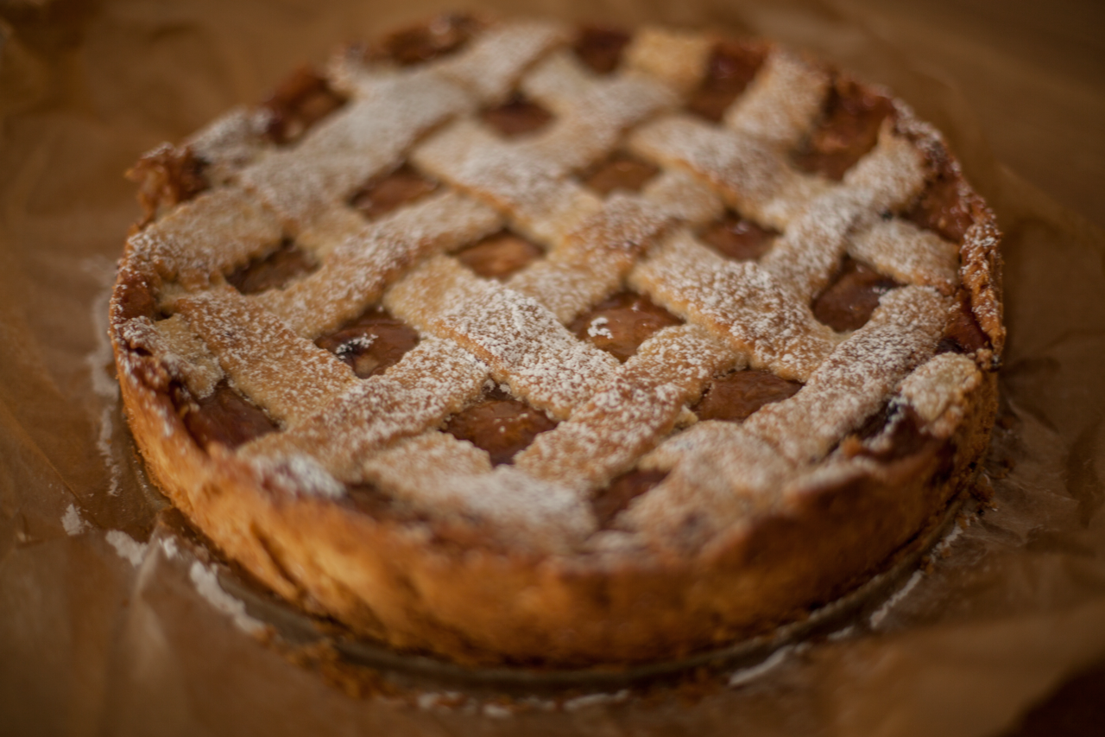

Recipe created by anszelika

APPLE PIE
Apple pie is a very popular and common kind of cake prepared in Polish houses. It is easy to make, because Poland is a great producer of apples.  Preparation:  DOUGH:  In a large bowl, mix together all ingredients with hand. Knead dough until smooth.  Divide into two pieces, wrap them into paper and put them into a freezer for at least 1,5 hours.  Prepare the baking tin with the pinch of fat (butter or margarine). Take one part of the dough out of the freezer and place it on the bottom of baking pan. You can make little holes with a fork in the dough, bake in the oven for about 15 minutes (180°C).  STUFFING:  Prepare half a kilo of apples. Peel the apples. Cut them into quarters and then into smaller pieces. Put the apples into a pot, pour half a glass of water and simmer the apples for at least 15 minutes.  After 15 minutes add half a glass of icing sugar, one table spoon of cinnamon, one tablespoon of fresh lemon juice. Stir the mixture and simmer it for another 5 minutes.  In the end add two tablespoons of potato flour, bring it to the boiling point and then turn the heating off.  FINAL STEPS:  On the baked bottom of cake put the apple mixture, cover it with the second part of the dough. Finally, bake it in the oven for an hour (180°C).  time KCal People Style Type Level Cost  2,5 - 3 hours 319 kcal 10 other dessert easy cheap | Ingredients:  Dough:  4 glasses of flour  2 teaspoons of baking powder  3/4 packet of butter  1 glass of sugar  1 packet of vanila sugar  2 eggs  2 yolks  3 table spoons of cream  Stuffing:  3 kilo of apples  1/2 glass of icing sugar  1 teaspoon of cinnamon  1 teaspoon of the fresh lemon juice  2 table spoons of potato flour  History:  The person in my family who popularised the recipe for the apple pie was my great grandmother. She lived in the Galicia Partition, where a usual custom was to make German strudel with apples. My great grandmother, and then the other women in my family, modernized the recipe, thanks to itwe can taste today this delicious szarlotka - apple pie.  Tips:  For a healthier and lighter version of apple pie, you can use natural yoghurt instead of cream, and you can use honey instead of sugar.  For a healthier and lighter version of apple pie, you can use natural yoghurt instead of cream, and you can use honey instead of sugar.

Canelés Bordelais
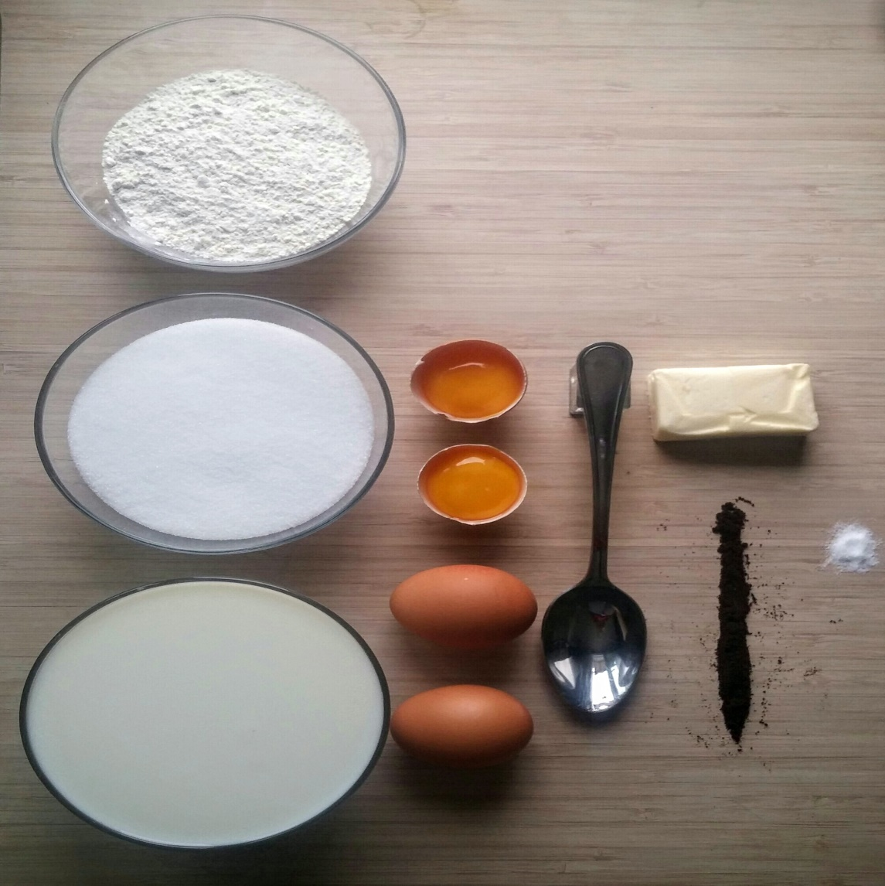 | 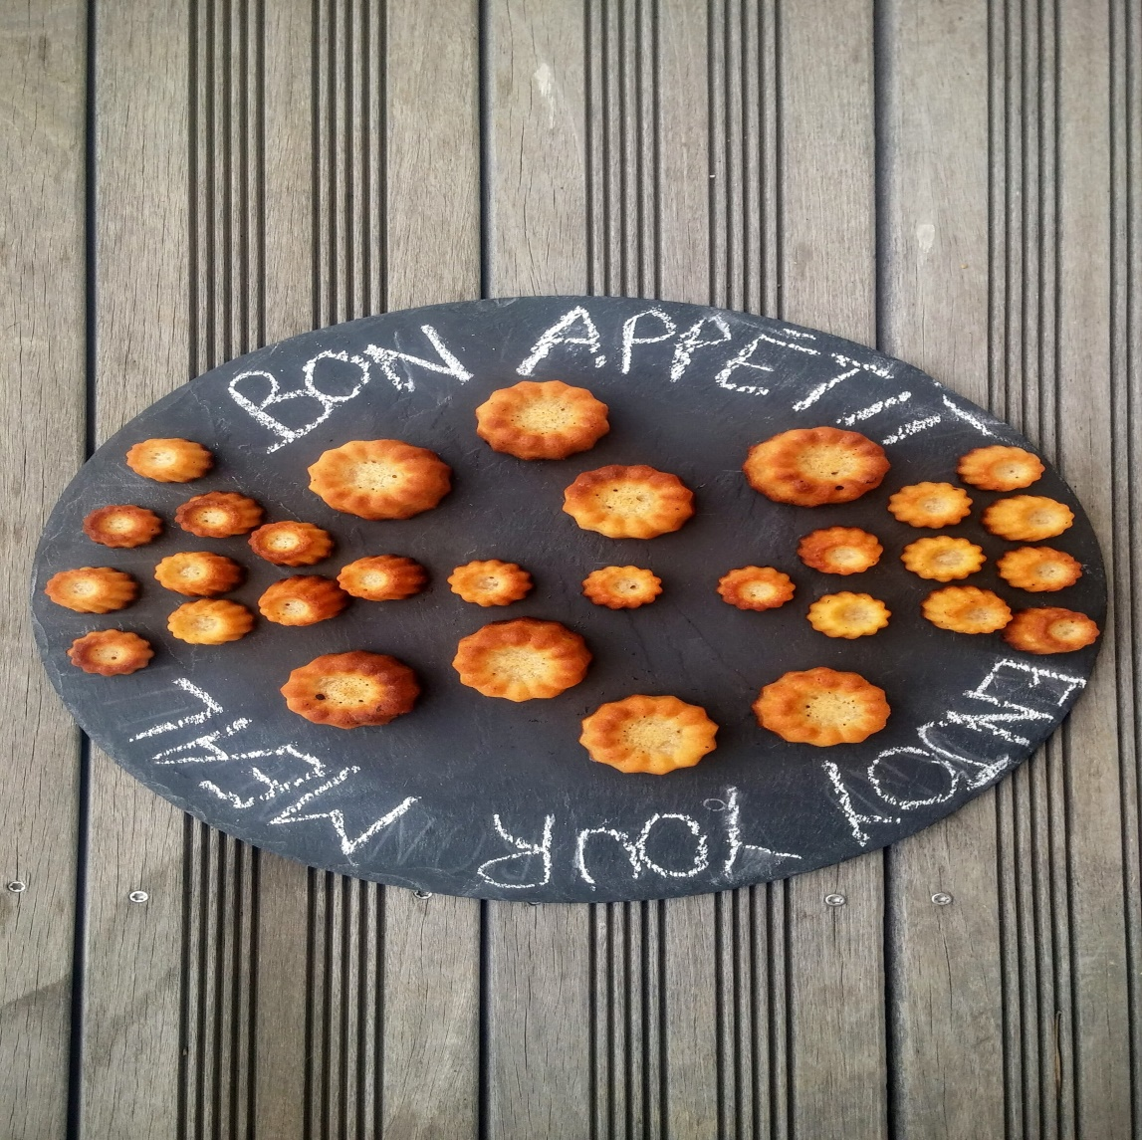

Recipe created by Lou-Anne

Caneles Bordelais
time | KCal | People | Style | Type | Level | Cost
 |  |  | other | dessert | easy | cheap

Sernik
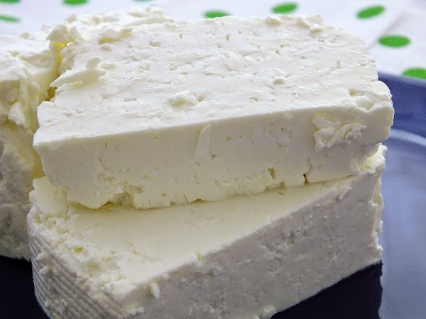 | 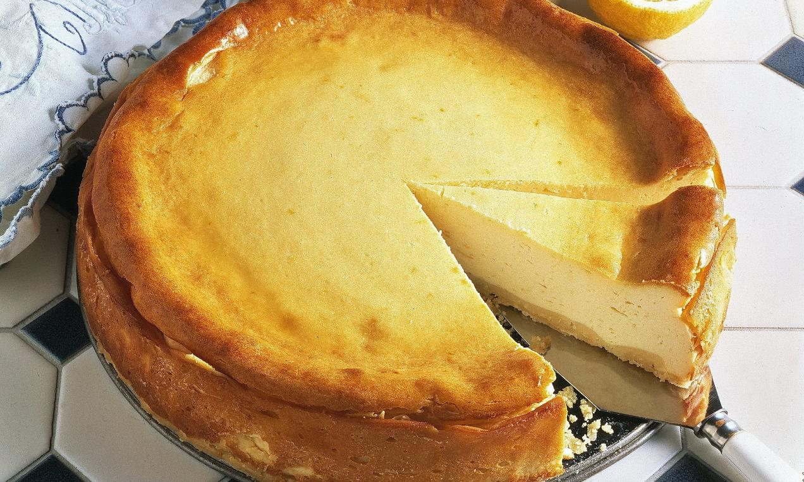

Recipe created by Aga Drewniak

Cheesecake
Cheesecake is a type of cake, thats main ingredient is cottage cheese cream. There are a lot of different cheesecake types, for example  Preparation:  Beat the egg yolks with 1 cup of sugar, then combine the mixture with separately grated butter. Mix thoroughly with cheese and custard. In the end add the whipped foam of whites with 1 cup of sugar. Combine all the ingredients, pour into a cake tin (27cm size). Bake for about an hour in the oven at 180 degrees.  time KCal People Style Type Level Cost  2 hours 321 kcal 8-10 other dessert easy cheap | Ingredients:  1 kg of cottage cheese cream (for example president)  2 cups of sugar  vanilla pudding  9 eggs  200g of butter  History:  The original version of cheesecake was baked with the use of minced fat cottage cheese, what made it tight. Cheesecake baked with cottage cheese (president) becomes plumper, softer thus also tastier. It melts in your mouth.  Tips:  Cheesecake tastes even better if it is poured with the mousse of raspberries or strawberries. It is therefore refreshing and tastier.  Cheesecake tastes even better if it is poured with the mousse of raspberries or strawberries. It is therefore refreshing and tastier.

Herrencreme

Recipe created by Linda Bahun

Herrencreme
Cream pudding with chocolate flakes.  Preparation:  Heat the milk until it is boling. Mix the pack of custard, the sugar and the salt in a separated bowl. Put it in the boiling milk and let it boil for a short time. Pour it into a bowl while you stir it. White until it is cold. After that whip the cream and crush the chocolate. When the pudding is cold, fold the chocolate and the cream carefully. Fill it in portion cups and refrigerate.  time KCal People Style Type Level Cost  1 hour 2051 4 other dessert easy cheap | Ingredients:  1/2 L milk  1 pack custard  4 Ts. suger  1 Prize salt  0,25 L cream  a bar of milk-chocolate  a bar of dark-chocolate

Tortitas
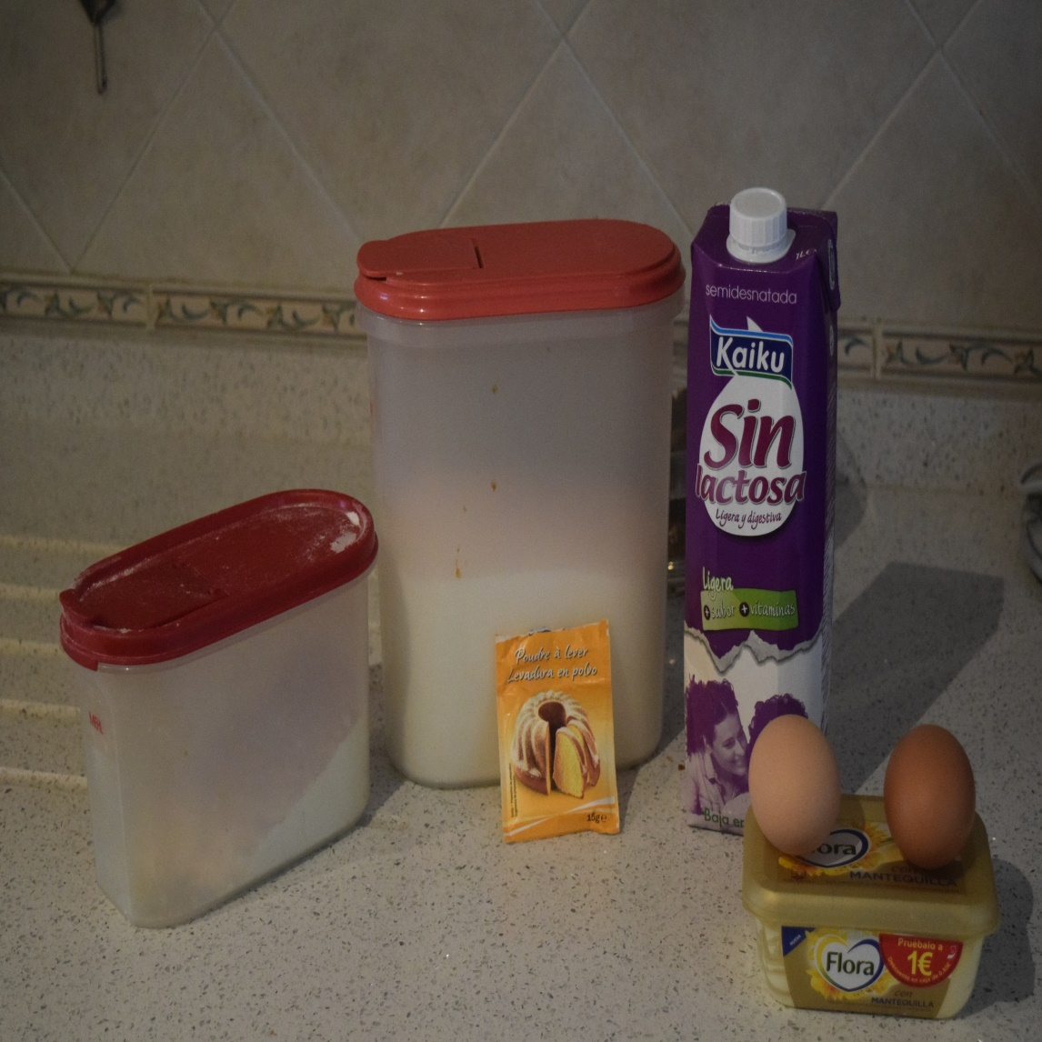 | 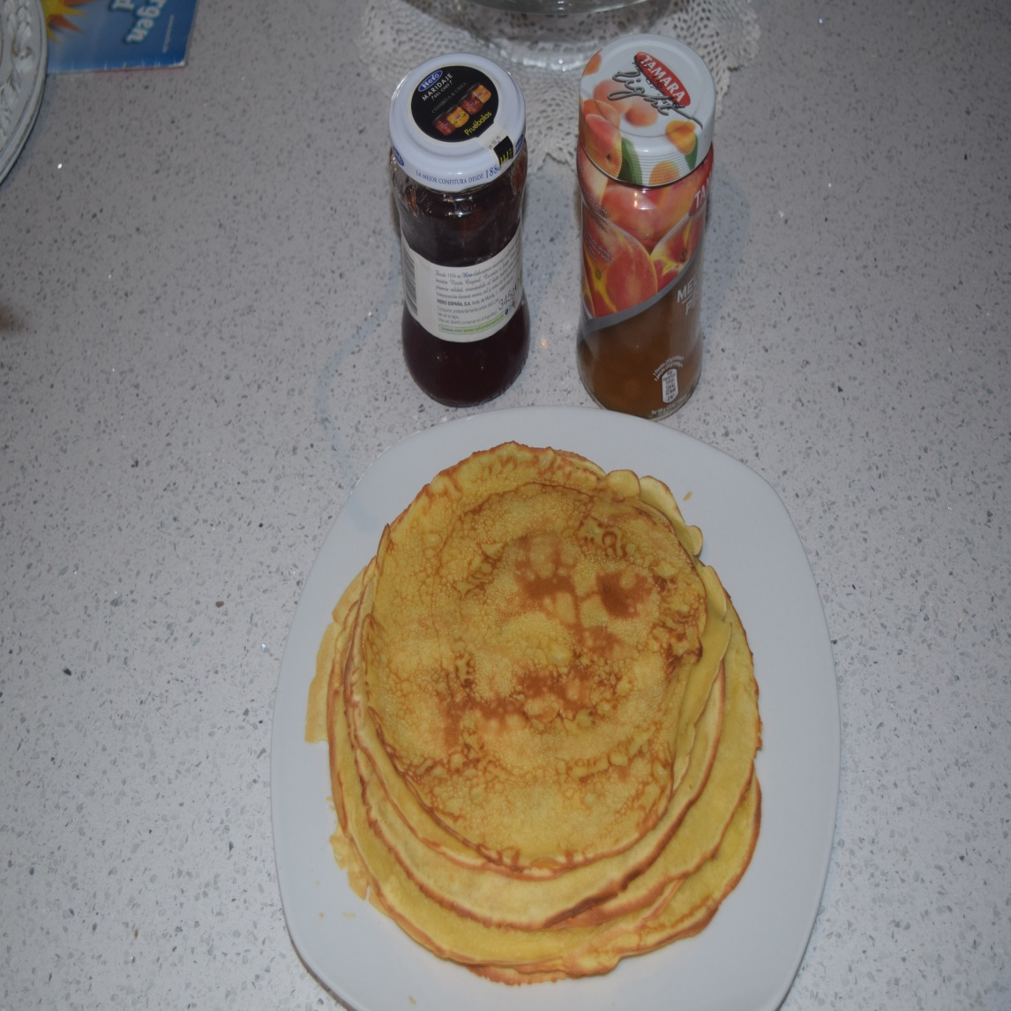

Recipe created by Jorge y Sergio

Pancakes
The pancakes, is a good dish for breakfast.  Preparation:  1º We put 50 grams low fat butter into the bowl  2º Add 300 grams of lactose-free milk  3º We add 2 eggs into the bowl  4º Put 30 grams sugar  5º take 200 grams flour and put into the bowl  6º add 1 teaspoon of backing powder into the bowl  7º Now mix all the ingredients and you will get a mixture like this we take a fry pan and add a little bit in it  8 ofter that we add also a little of the mixture from before in the frying pan  9º When you see that the pancake has a golden to light brown in colour, it means thar its to take pancake and put it in plate  time KCal People Style Type Level Cost  20min 5 other dessert easy cheap | Ingredients:  - Butter (50 grams)  - milk (300 grams)  - eggs (2 eggs)  - sugar (200 grams)  - backing powder (1 teaspoon)

Racuchy

Recipe created by Kasia Kaca

Polish Apples Pancakes
This is a simple, fast dish. Served both as a dessert or as lunch.  Preparation:  First prepare the apples. Peel them and grate them or slice into small pieces. Break eggs into two separate bowls – one with yolks and the other with whites. Beat whites to stiff. In a big bowl mix together milk, yolks, flour, sugar and salt, stir all the ingredients to get smooth, dense mass. Add baking soda and grated apples. In the end, add whites and gently mix. Fry in hot oil.  time KCal People Style Type Level Cost  about 20 minutes 308 4 other dessert easy cheap | Ingredients:  1/2 litre of milk  2 eggs  flour  1 teaspoon of sugar  pinch of salt  apples  History:  In our kitchen there is a very long time.So that became a tradicional Polish dish. Their preparation is simple and fast ,so that often apper on the Polish table  Tips:  Serve on a plate with powdered sugar or jam.  Serve on a plate with powdered sugar or jam.

